SIR C R REDDY COLLEGE OF ENGINEERING
DEPARTMENT OF ELECTRICAL AND ELECTRONICS ENGINEERING
ASSIGNMENT-2 1st Semester AY: 2016-17
Subject : ACS (EEE-416) Class : IV/IV EEE (A)
Group-1

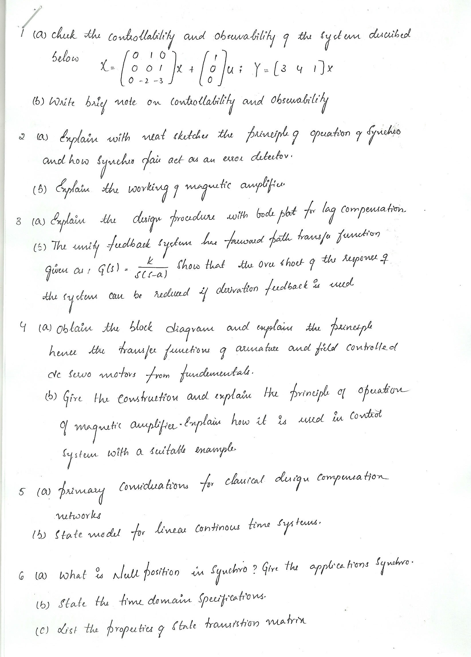



Group-2
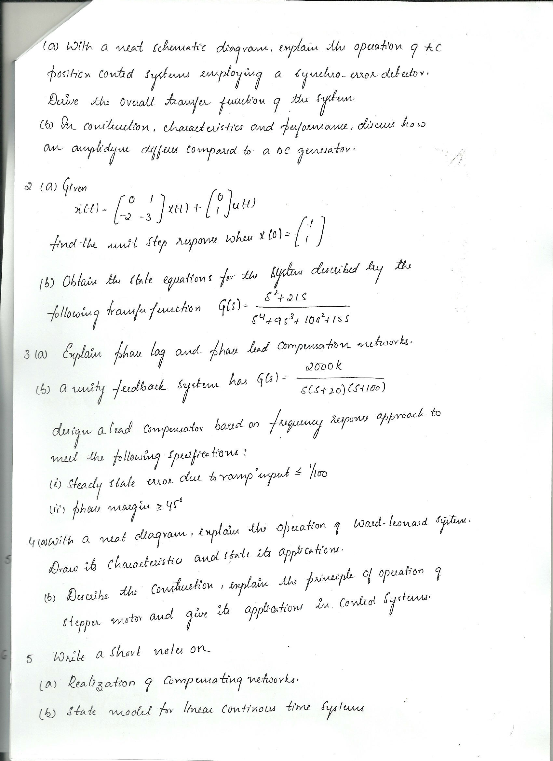

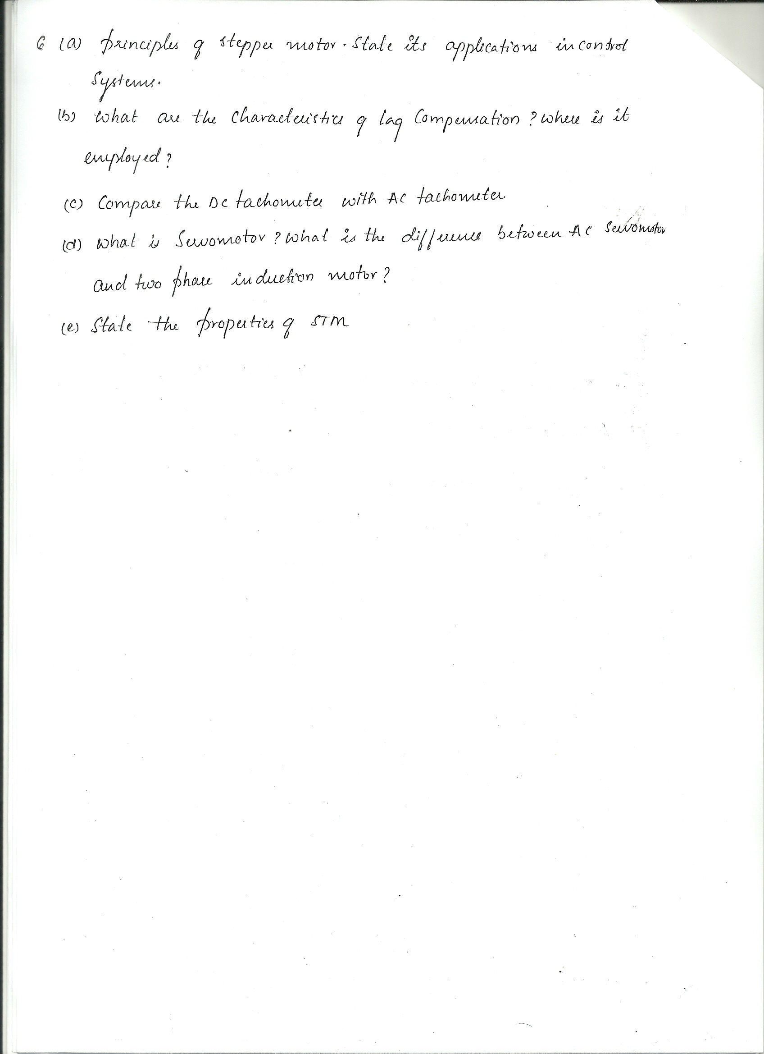

Group-3
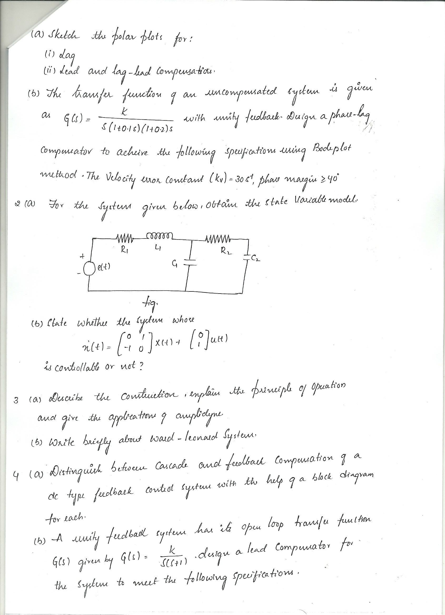

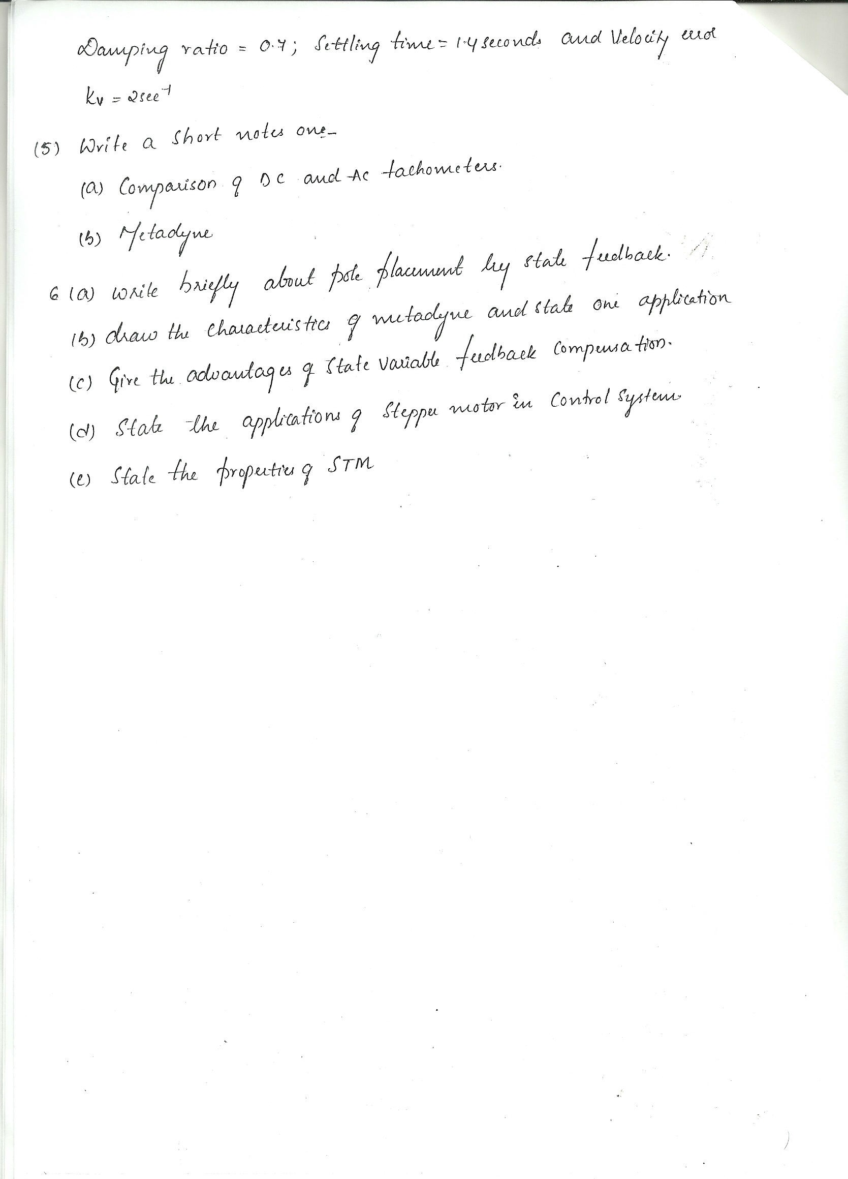

Group-4
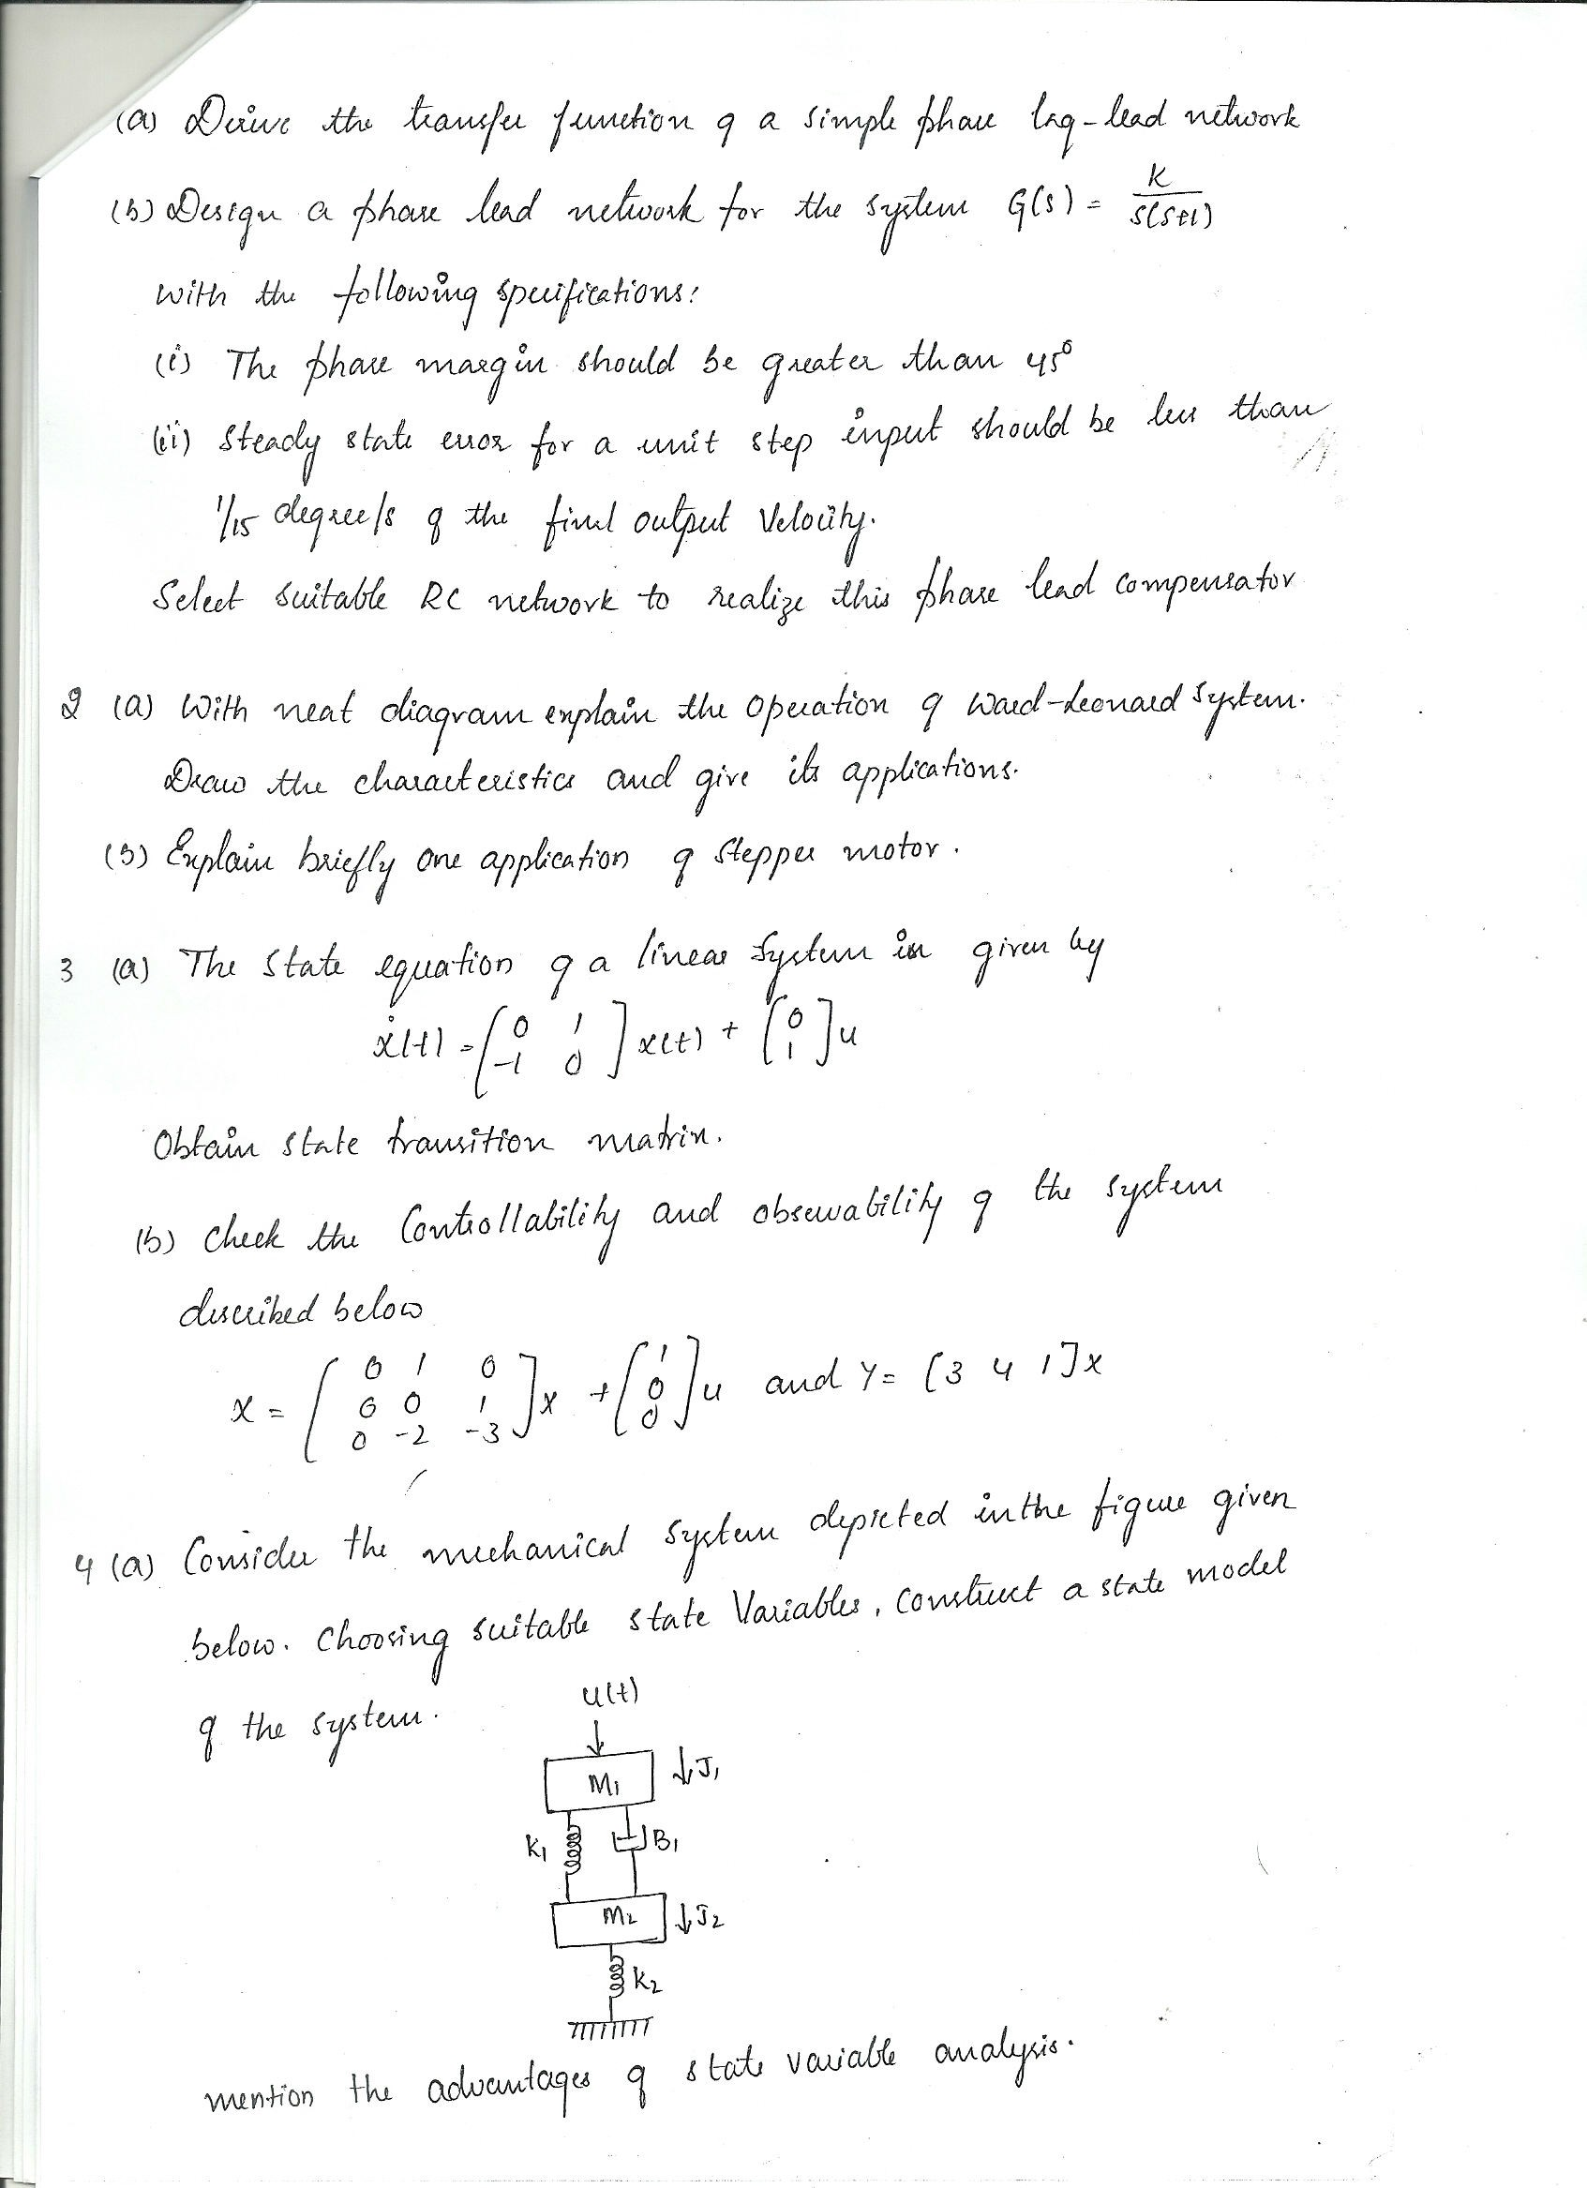

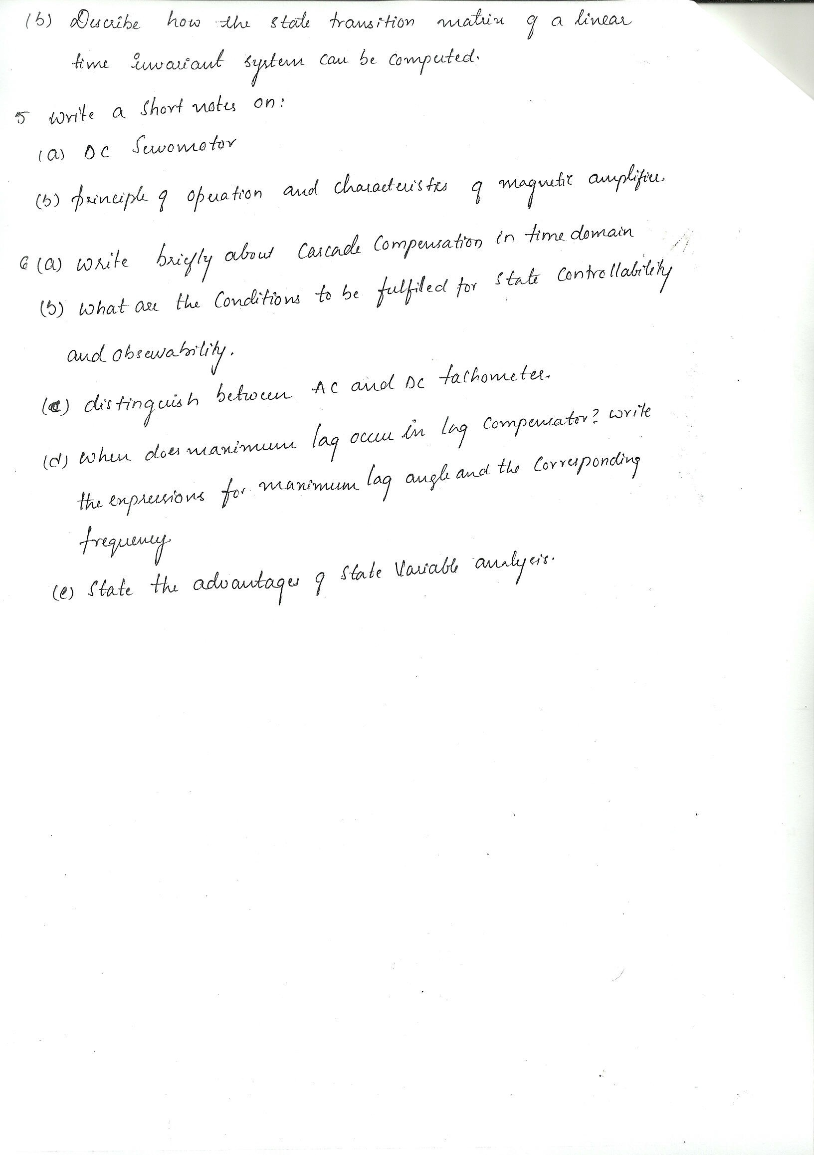

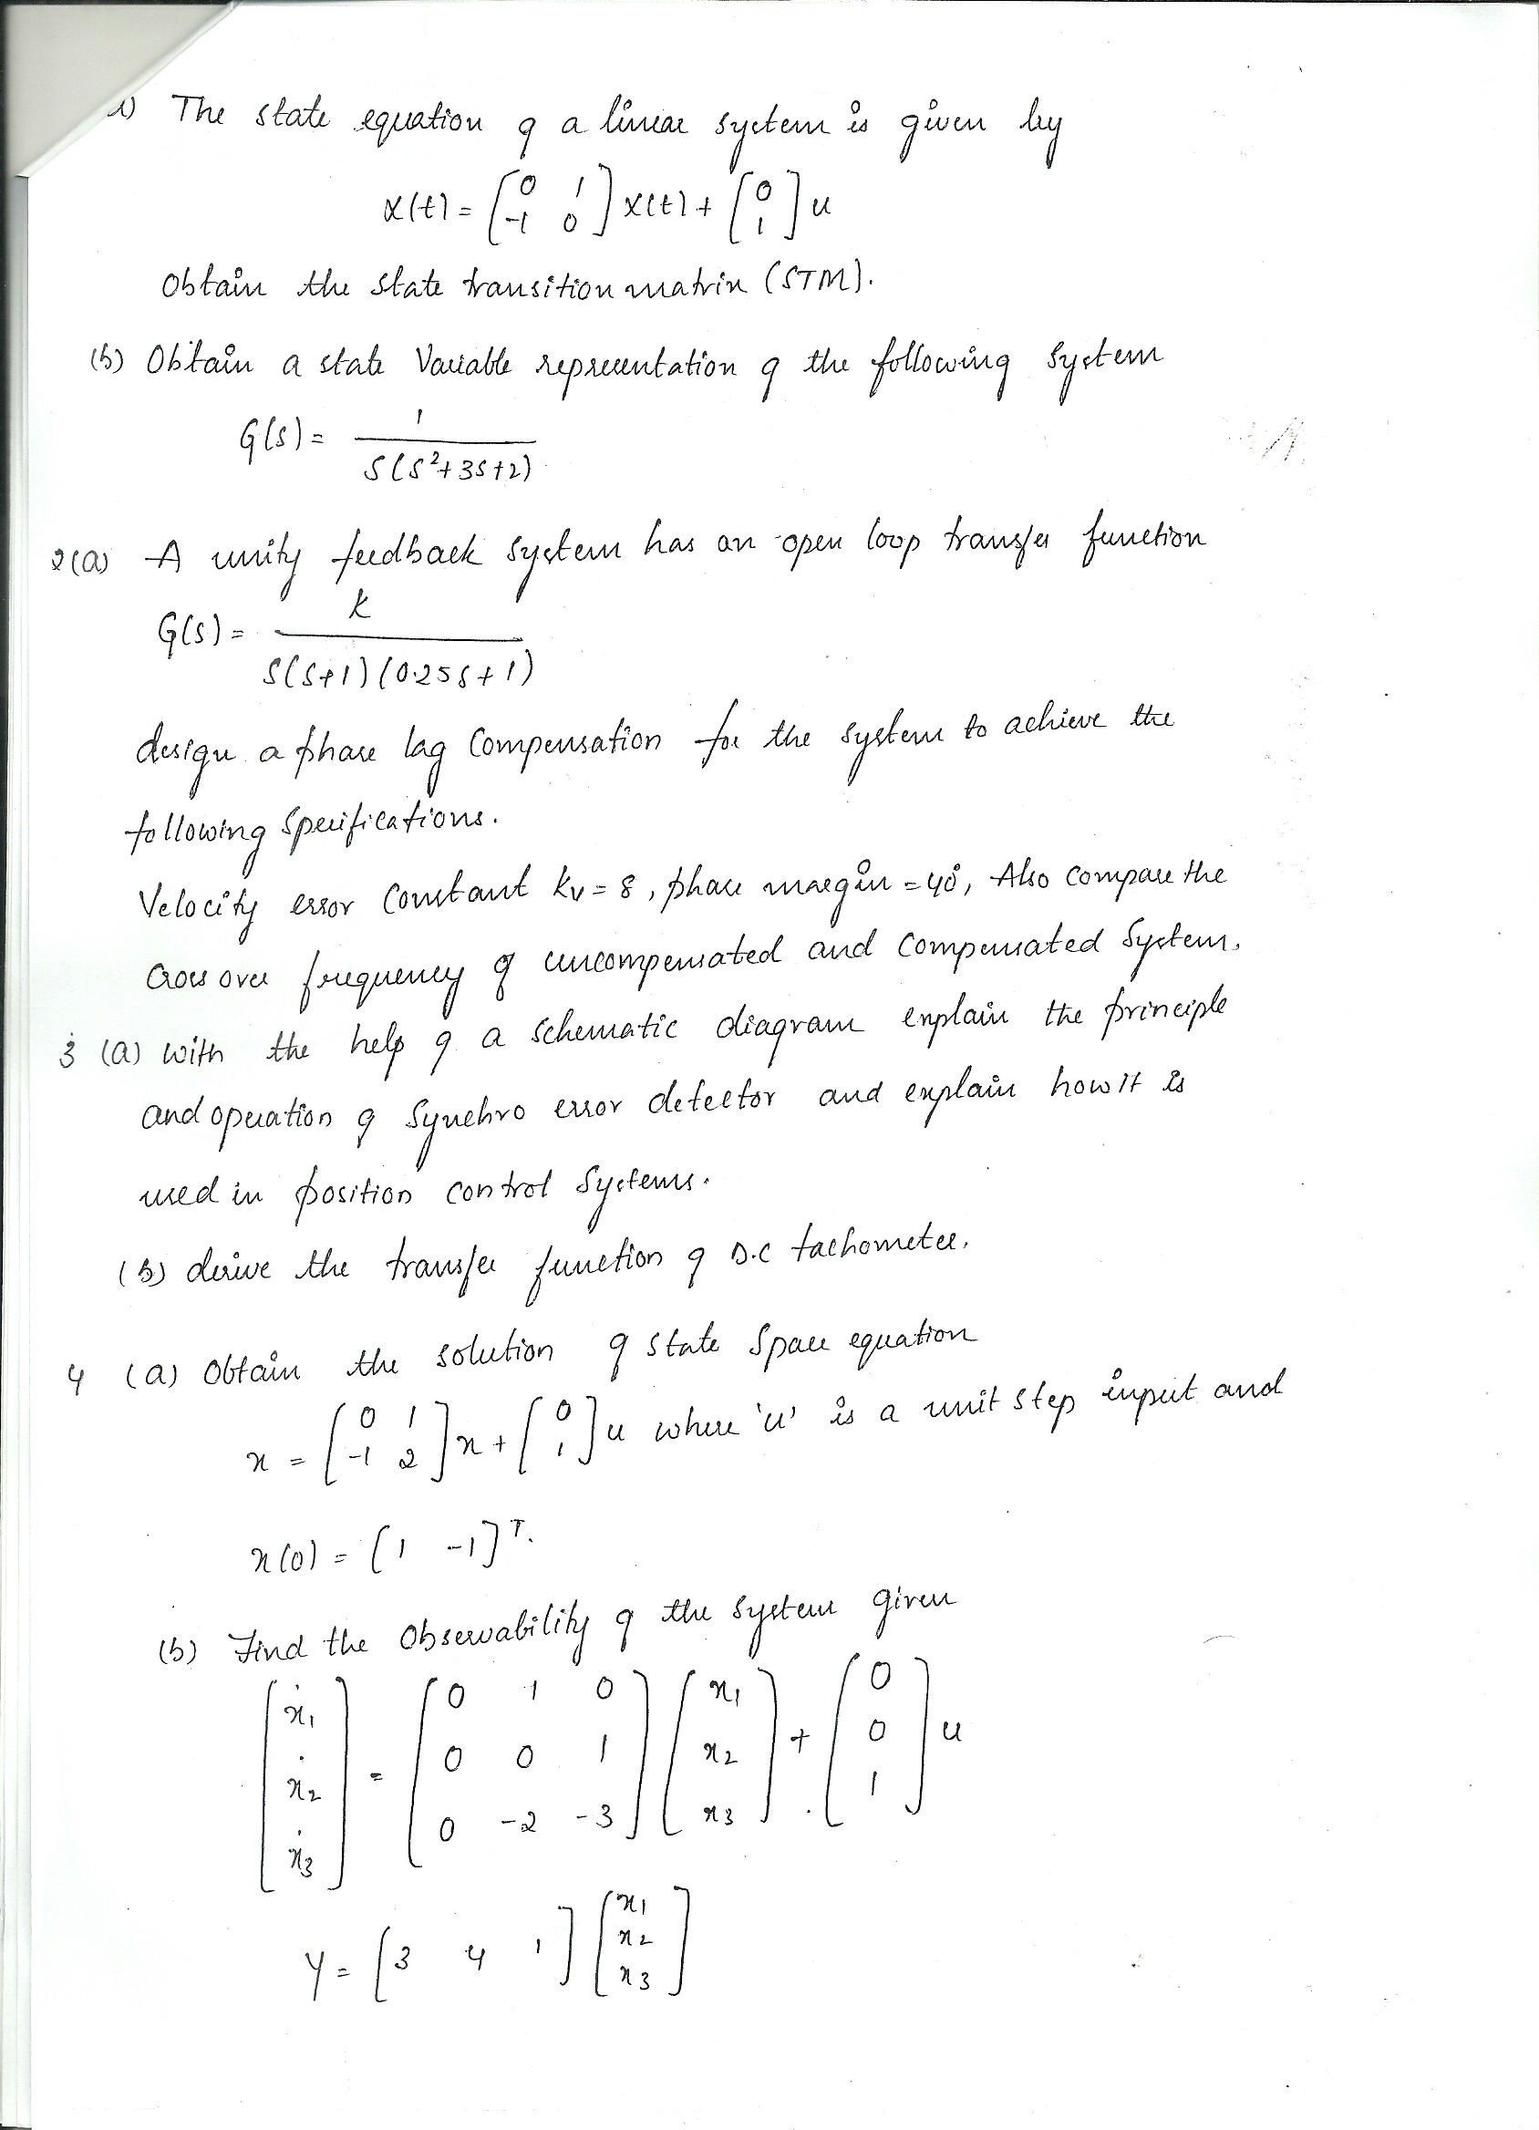
Group-5



