SIR C R REDDY COLLEGE OF ENGINEERING
DEPARTMENT OF ELECTRICAL & ELECTRONICS ENGINEERING
II Assignment; I Semester AY: 20015-16
Subject : Electromagnetics Class : II/IV EEE (Sec-B)
Group -1
1 Derive the expression for energy density in electrostatic fields
2 Derive the relation between E and V from fundamentals.
3 Classify the magnetic materials based on magnetic susceptibility and relative
permeability with examples.
4 Define and explain Scalar and Vector magnetic potentials.
5 Derive magnetic boundary conditions and prove that 2
1
2
1
􀁐
􀁐
􀁔
􀁔
􀀠
Tan
Tan
.
6 Show that the vector product P 􀀠 E 􀁵 H represents the rate of energy flow per unit area
at a point.
7 If E xy 2ax x2ay
1 􀀠 􀀎 􀀐 , Find i) Electric flux density D and ii) Volume charge
density ρ
8 Write short notes on
i) Maxwell’s modification of ampere’s law.
ii) Gauss’s law in terms of E (integral form and differential form)
9 Region 1, for which 􀁐r1 􀀠 3is defined by x<0 and region 2, x>0, has 􀁐r2 􀀠 5 .
Given H1 􀀠 4ax 􀀎 3ay 􀀐 6az Amp/m. Show that 􀁔2 =19.70 and H=7.12 A/m.
10 Find the magnetic field on the axis of a circular current loop of radius R. Specialize the
result to the centre of the loop
SIR C R REDDY COLLEGE OF ENGINEERING
DEPARTMENT OF ELECTRICAL & ELECTRONICS ENGINEERING
II Assignment; I Semester AY: 20015-16
Subject : Electromagnetics Class : II/IV EEE (Sec-B)
Group -2
1 Derive the expression for the capacitance of a co-axial cylinder.
2 Define the terms
i) Electric flux density
ii) Potential difference
iii) Potential gradient
Also obtain the relation between electric field and potential
3 What is linear, homogeneous and isotropic dielectric? How polarization in a dielectric
effect the electric field?
4 Find H on the axis of a circular loop of radius ‘R’ at a distance‘d’ from the centre
carrying a current of I amperes in the counter clockwise direction. Specialize the result to
the centre of the loop
5 A magnetic field B a z 􀀠 3.5 􀁵10􀀐2 wb/m2 exerts a force on a 0.3m conductor along
the X-axis. If the conductor current is 5 amps in the ax direction, what force must be
applied to hold the conductor in position?
6 State and explain ampere’s circuital law. A circuit carrying a current of I amperes form a
regular polygon of ‘n’ sides inscribed in a circle of radius ‘R’. Calculate the magnetic
flux density B at the centre of the polygon.
7 Derive the expression for the energy stored in a magnetic field.
8 A square coil with loop area o.o1 sq.m. has 50 turns is rotated about its axis, at right
angles to a uniform magnetic field B =1 wb/m2. Calculate the instantaneous value of the
e.m.f. in the coil when its plane is i) at right angles to the field ii) at 450 to the field and
iii) in the plane of the field. Speed of rotation =1000rpm.
9 Find the average pointing vector for a plane wave of amplitude of Ho=1 ampere/meter in
a homogeneous isotropic medium for which 1 r 􀁐 􀀠 and ε 4 r 􀀠 . Find also the maximum
energy density of this wave.
10 Derive the relation between E and V from fundamentals.
SIR C R REDDY COLLEGE OF ENGINEERING
DEPARTMENT OF ELECTRICAL & ELECTRONICS ENGINEERING
II Assignment; I Semester AY: 20015-16
Subject : Electromagnetics Class : II/IV EEE (Sec-B)
Group -3
1 Derive E and V for an electric dipole.
2 State and derive boundary conditions in an electrostatic field.
3 A potential function is given by V= 2 2 2
20
x 􀀎 y 􀀎 z . Determine the electric field in the
general form and also the particular values in the vector form at the point (5, 3,0).
4 Derive the continuity equation for current.
5 Derive the wave equation 2
2
0 0
2
t
H H
􀁷
􀁷
􀂒 􀀠 􀁐 􀁈
6 A linear conductor carries a current of 100 amperes in the positive z-direction. If the
flux density everywhere is uniform with a magnitude of B=2.5 Wb/m2 and has direction
parallel to the X-Y plane and at an angle of 300 with respect to X-axis; find the
magnitude and direction of force on a 2 meter length of the conductor.
7 Explain why Ampere’s law has to modified when the fields very with time
i) Considering the point form; and ii) the integral form of the law. How is it modified?
8 Medium -1 has 􀁈 r1 􀀠 1.5 extends to the left of y-z plane, medium -2 has 􀁈 r2 􀀠2.5 and
extends to the right of y-z plane if E1 􀀠 2ax 􀀎 3ay 􀀎1az find the magnitude of
E2 and angle 􀁔2
9 Region 1, for which 􀁐r1 􀀠 3is defined by x<0 and region 2, x>0, has 􀁐r2 􀀠 5 .
Given H1 􀀠 4ax 􀀎 3ay 􀀐 6az Amp/m. Show that 􀁔2 =19.70 and H=7.12 A/m.
10 Show that in a condenser, the displacement current is equal to its conduction current.
SIR C R REDDY COLLEGE OF ENGINEERING
DEPARTMENT OF ELECTRICAL & ELECTRONICS ENGINEERING
II Assignment; I Semester AY: 20015-16
Subject : Electromagnetics Class : II/IV EEE (Sec-B)
Group -4
1 Starting from fundamentals, Derive laplace’s and Poisson’s equation in static electric
fields
2 Find the Electric Field due to infinite sheet of a charge.
3 The gradient of a scalar electric potential function is given by
􀀾 􀁀 V 3 (x yz)ax ( y zx)ay (z xy)az 􀂒 􀀠 2 􀀐 􀀎 2 􀀐 􀀎 2 􀀐
If the point (1, 1, 1,) is at zero potential, determine the potential function V.
4 State and prove ampere’s circuital law.
5 Write Maxwell’s equations for time varying fields and convert them into harmonically
varying fields. (Both integral and point form)
6 Derive the wave equation 2
2
0 0
2
t
E E
􀁷
􀁷
􀂒 􀀠 􀁐 􀁈
7 An infinitely long straight wire carrying current of I amperes lies along the Z-axis.
Obtain magnetic vector potential due to the wire and then find the magnetic flux
density.
8 The region y>0 contains a dielectric material for which 3 1 􀀠 r 􀁈 and in the region y<0,
5 2 􀀠 r 􀁈 . If x y z E 20a 30a 40a 1 􀀠 􀀎 􀀐 volts /meter, find 2 2 D and 􀁔
9 Three point charges 1, 2, and 3 coulombs are situated in free space at the corners of an
equilateral triangle of side one meter. Find the energy stored in the system.
10 Explain method of images considering point charge.
SIR C R REDDY COLLEGE OF ENGINEERING
DEPARTMENT OF ELECTRICAL & ELECTRONICS ENGINEERING
II Assignment; I Semester AY: 20015-16
Subject : Electromagnetics Class : II/IV EEE (Sec-B)
Group -5
1 A point charge Q1= - 10nC is located at origin. If x-component of electric filed intensity
is zero at (3, 1, 1), what charge QT, should be the kept at the point (2, 1, 0).
2 The electric potential function V is given by
V=2(x+1)2(y+2)2(z+3)2 in free space.
Calculate i) Potential ii) Electric Field Intensity and iii) Volume charge density at point
(1, 2, 3)
3 Derive boundary conditions for electrostatic fields
4 Derive the expression for the force between two long and parallel conductors carrying
currents I1 and I2 in the same direction.
5 Two concentric conducting spheres are located at r=3mm and r=5mm. The region
between the spheres is filled with a perfect dielectric. If the inner sphere is at 100V and
outer sphere of 20 Volts. Find the electric field intensity between the spheres.
6 write short notes on
i) Faradays law of induction
ii) Polarization of dielectrics.
7 Comparison of electrostatics and magnetostatics.
8 Derive an expression for pointing vector. Show how this can be used to calculate the
power.
9 Explain the properties of diamagnetic and paramagnetic materials.
10 A point charge 3 μc is placed 1cm from a conducting plane. Using method of images,
Compute the electric filed and the charge density on the conducting plane at a distance of
3cm from the point charge.
SIR C R REDDY COLLEGE OF ENGINEERING
DEPARTMENT OF ELECTRICAL & ELECTRONICS ENGINEERING
II Assignment; I Semester AY: 20015-16
Subject : Electromagnetics Class : II/IV EEE (Sec-B)
Group -6
1 Derive the expression for electric field intensity due uniform line charge configuration
using direct integration.
2 Find B at the centre of a square loop of side ’L’ meters carrying a current I amperes in
the anticlockwise direction.
3 In a certain region, the expression for potential is given by V 􀀠 3x2 y 􀀐 4y2 z 􀀎 9 . Find
the intensity of electric field in general form and at point, P (-1, 2, -3) m
4 Given E 􀀠 􀀐3 a x 􀀎 4 a y 􀀐 2 a z V/m in the region Z < 0, where 2 r 􀁈 􀀠 , Find E in the
region Z > 0, for which 6.5 r 􀁈 􀀠
5 Find the average pointing vector for a plane wave of amplitude of Ho=1 ampere/metre in
a homogeneous isotropic medium for which 1 r 􀁐 􀀠 and ε 4 r 􀀠 . Find also the maximum
energy density of this wave.
6 Show that intrinsic impedance of uniform plane wave in free space is 377Ω.
7 Show that the conduction current is equal to the displacement current in a parallel plate
capacitor when it is connected to a sinusoidal voltage.
8 A copper wire conducts a conduction current of 1 ampere. Determine the displacement
current in the wire at 100 MHz. Take ε=ε0 and σ = 5.8 x 10-7 mho/meter
9 A linear conductor carries a current of 100 amperes in the positive z-direction. If the flux
density everywhere is uniform with a magnitude of B=2.5 Wb/m2 and has direction
parallel to the X-Y plane and at an angle of 300 with respect to X-axis; find the
magnitude and direction of force on a 2 meter length of the conductor.
10 Medium -1 has 􀁈 r1 􀀠 1.5 extends to the left of y-z plane, medium -2 has 􀁈 r2 􀀠2.5 and
extends to the right of y-z plane if E1 􀀠 2ax 􀀎 3ay 􀀎1az find the magnitude of
E2 and angle 􀁔2
SIR C R REDDY COLLEGE OF ENGINEERING
DEPARTMENT OF ELECTRICAL & ELECTRONICS ENGINEERING
II Assignment; I Semester AY: 20015-16
Subject : Electromagnetics Class : II/IV EEE (Sec-C)
Group -1
1 Find the Electric Field due to infinite sheet of a charge.
2 State and derive boundary conditions in an electrostatic field.
3 A potential function is given by V= 2 2 2
20
x 􀀎 y 􀀎 z . Determine the electric field in the
general form and also the particular values in the vector form at the point (5, 3,0).
4 Derive the continuity equation for current.
5 Derive the wave equation 2
2
0 0
2
t
H H
􀁷
􀁷
􀂒 􀀠 􀁐 􀁈
6 A linear conductor carries a current of 100 amperes in the positive z-direction. If the
flux density everywhere is uniform with a magnitude of B=2.5 Wb/m2 and has direction
parallel to the X-Y plane and at an angle of 300 with respect to X-axis; find the
magnitude and direction of force on a 2 meter length of the conductor.
7 Explain why Ampere’s law has to modified when the fields very with time
i) Considering the point form; and ii) the integral form of the law. How is it modified?
8 Medium -1 has 􀁈 r1 􀀠 1.5 extends to the left of y-z plane, medium -2 has 􀁈 r2 􀀠2.5 and
extends to the right of y-z plane if E1 􀀠 2ax 􀀎 3ay 􀀎1az find the magnitude of
E2 and angle 􀁔2
9 If E xy 2ax x2ay
1 􀀠 􀀎 􀀐 , Find i) Electric flux density D and ii) Volume charge
density ρ
10 Explain method of images considering point charge.
SIR C R REDDY COLLEGE OF ENGINEERING
DEPARTMENT OF ELECTRICAL & ELECTRONICS ENGINEERING
II Assignment; I Semester AY: 20015-16
Subject : Electromagnetics Class : II/IV EEE (Sec-C)
Group -2
1 Starting from fundamentals, Derive laplace’s and Poisson’s equation in static electric
fields
2 Derive E and V for an electric dipole.
3 The gradient of a scalar electric potential function is given by
􀀾 􀁀 V 3 (x yz)ax ( y zx)ay (z xy)az 􀂒 􀀠 2 􀀐 􀀎 2 􀀐 􀀎 2 􀀐
If the point (1, 1, 1,) is at zero potential, determine the potential function V.
4 State and prove ampere’s circuital law.
5 Write Maxwell’s equations for time varying fields and convert them into harmonically
varying fields. (Both integral and point form)
6 Derive the wave equation 2
2
0 0
2
t
E E
􀁷
􀁷
􀂒 􀀠 􀁐 􀁈
7 An infinitely long straight wire carrying current of I amperes lies along the Z-axis.
Obtain magnetic vector potential due to the wire and then find the magnetic flux
density.
8 The region y>0 contains a dielectric material for which 3 1 􀀠 r 􀁈 and in the region y<0,
5 2 􀀠 r 􀁈 . If x y z E 20a 30a 40a 1 􀀠 􀀎 􀀐 volts /meter, find 2 2 D and 􀁔
9 Three point charges 1, 2, and 3 coulombs are situated in free space at the corners of an
equilateral triangle of side one meter. Find the energy stored in the system.
10 Show that in a condenser, the displacement current is equal to its conduction current.
SIR C R REDDY COLLEGE OF ENGINEERING
DEPARTMENT OF ELECTRICAL & ELECTRONICS ENGINEERING
II Assignment; I Semester AY: 20015-16
Subject : Electromagnetics Class : II/IV EEE (Sec-C)
Group -3
1 Derive the expression for energy density in electrostatic fields
2 Derive the relation between E and V from fundamentals.
3 Classify the magnetic materials based on magnetic susceptibility and relative
permeability with examples.
4 Define and explain Scalar and Vector magnetic potentials.
5 Derive magnetic boundary conditions and prove that 2
1
2
1
􀁐
􀁐
􀁔
􀁔
􀀠
Tan
Tan
.
6 Show that the vector product P 􀀠 E 􀁵 H represents the rate of energy flow per unit area
at a point.
7 In cylindrical coordinate a􀁉
r
B 􀀠 2 (T). Determine the magnetic flux crossing the plane
surface defined by 0.5 ≤ r ≤ 2.5m and 0 ≤ z ≤ 2.0m.
8 Write short notes on
i) Maxwell’s modification of ampere’s law.
ii) Gauss’s law in terms of E (integral form and differential form)
9 Region 1, for which 􀁐r1 􀀠 3is defined by x<0 and region 2, x>0, has 􀁐r2 􀀠 5 .
Given H1 􀀠 4ax 􀀎 3ay 􀀐 6az Amp/m. Show that 􀁔2 =19.70 and H=7.12 A/m.
10 Find the magnetic field on the axis of a circular current loop of radius R. Specialize the
result to the centre of the loop
SIR C R REDDY COLLEGE OF ENGINEERING
DEPARTMENT OF ELECTRICAL & ELECTRONICS ENGINEERING
II Assignment; I Semester AY: 20015-16
Subject : Electromagnetics Class : II/IV EEE (Sec-C)
Group -4
1 Derive the expression for the capacitance of a co-axial cylinder.
2 Define the terms
i) Electric flux density
ii) Potential difference
iii) Potential gradient
Also obtain the relation between electric field and potential
3 what is linear, homogeneous and isotropic dielectric? How polarization in a
dielectric effect the electric field?
4 Find H on the axis of a circular loop of radius ‘R’ at a distance‘d’ from the centre
carrying a current of I amperes in the counter clockwise direction. Specialize the
result to the centre of the loop
5 A magnetic field B a z 􀀠 3.5 􀁵10􀀐2 wb/m2 exerts a force on a 0.3m conductor
along the X-axis. If the conductor current is 5 amps in the ax direction, what
force must be applied to hold the conductor in position?
6 write short notes on
i) Faradays law of induction
ii) Polarization of dielectrics.
7 Comparison of electrostatics and magnetostatics.
8 Derive an expression for pointing vector. Show how this can be used to calculate
the power.
9 Explain the properties of diamagnetic and paramagnetic materials.
10 A point charge 3 μc is placed 1cm from a conducting plane. Using method of
images, Compute the electric filed and the charge density on the conducting plane
at a distance of 3cm from the point charge.
SIR C R REDDY COLLEGE OF ENGINEERING
DEPARTMENT OF ELECTRICAL & ELECTRONICS ENGINEERING
II Assignment; I Semester AY: 20015-16
Subject : Electromagnetics Class : II/IV EEE (Sec-C)
Group -5
1 A point charge Q1= - 10nC is located at origin. If x-component of electric filed intensity
is zero at (3, 1, 1), what charge QT, should be the kept at the point (2, 1, 0).
2 The electric potential function V is given by
V=2(x+1)2(y+2)2(z+3)2 in free space.
Calculate i) Potential ii) Electric Field Intensity and iii) Volume charge density at point
(1, 2, 3)
3 Derive boundary conditions for electrostatic fields
4 Derive the expression for the force between two long and parallel conductors carrying
currents I1 and I2 in the same direction.
5 Two concentric conducting spheres are located at r=3mm, and r=5mm. The region
between the spheres is filled with a perfect dielectric. If the inner sphere is at 100V and
outer sphere of 20 Volts. Find the electric field intensity between the spheres.
6 State and explain ampere’s circuital law. A circuit carrying a current of I amperes form a
regular polygon of ‘n’ sides inscribed in a circle of radius ‘R’. Calculate the magnetic
flux density B at the centre of the polygon.
7 Derive the expression for the energy stored in a magnetic field.
8 A square coil with loop area o.o1 sq.m. has 50 turns is rotated about its axis, at right
angles to a uniform magnetic field B =1 wb/m2. Calculate the instantaneous value of the
e.m.f. in the coil when its plane is i) at right angles to the field ii) at 450 to the field and
iii) in the plane of the field. Speed of rotation =1000rpm.
9 Find the average pointing vector for a plane wave of amplitude of Ho=1 ampere/meter in
a homogeneous isotropic medium for which 1 r 􀁐 􀀠 and ε 4 r 􀀠 . Find also the maximum
energy density of this wave.
10 A linear conductor carries a current of 100 amperes in the positive z-direction. If the flux
density everywhere is uniform with a magnitude of B=2.5 Wb/m2 and has direction
parallel to the X-Y plane and at an angle of 300 with respect to X-axis; find the
magnitude and direction of force on a 2 meter length of the conductor
SIR C R REDDY COLLEGE OF ENGINEERING
DEPARTMENT OF ELECTRICAL & ELECTRONICS ENGINEERING
II Assignment; I Semester AY: 20015-16
Subject : Electromagnetics Class : II/IV EEE (Sec-C)
Group -6
1 Derive the expression for electric field intensity due uniform line charge configuration
using direct integration.
2 Find B at the centre of a square loop of side ’L’ meters carrying a current I amperes in
the anticlockwise direction.
3 In a certain region, the expression for potential is given by V 􀀠 3x2 y 􀀐 4y2 z 􀀎 9 . Find
the intensity of electric field in general form and at point, P (-1, 2, -3) m
4 Given E 􀀠 􀀐3 a x 􀀎 4 a y 􀀐 2 a z V/m in the region Z < 0, where 2 r 􀁈 􀀠 , Find E in the
region Z > 0, for which 6.5 r 􀁈 􀀠
5 Find the average pointing vector for a plane wave of amplitude of Ho=1 ampere/metre in
a homogeneous isotropic medium for which 1 r 􀁐 􀀠 and ε 4 r 􀀠 . Find also the maximum
energy density of this wave.
6 Show that intrinsic impedance of uniform plane wave in free space is 377Ω.
7 Show that the conduction current is equal to the displacement current in a parallel plate
capacitor when it is connected to a sinusoidal voltage.
8 A copper wire conducts a conduction current of 1 ampere. Determine the displacement
current in the wire at 100 MHz. Take ε=ε0 and σ = 5.8 x 10-7 mho/meter
9 A linear conductor carries a current of 100 amperes in the positive z-direction. If the flux
density everywhere is uniform with a magnitude of B=2.5 Wb/m2 and has direction
parallel to the X-Y plane and at an angle of 300 with respect to X-axis; find the
magnitude and direction of force on a 2 meter length of the conductor.
10 Medium -1 has 􀁈 r1 􀀠 1.5 extends to the left of y-z plane, medium -2 has 􀁈 r2 􀀠2.5 and
extends to the right of y-z plane if E1 􀀠 2ax 􀀎 3ay 􀀎1az find the magnitude of
E2 and angle 􀁔2

Batch I
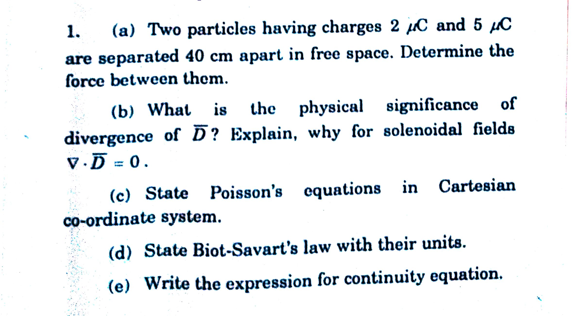
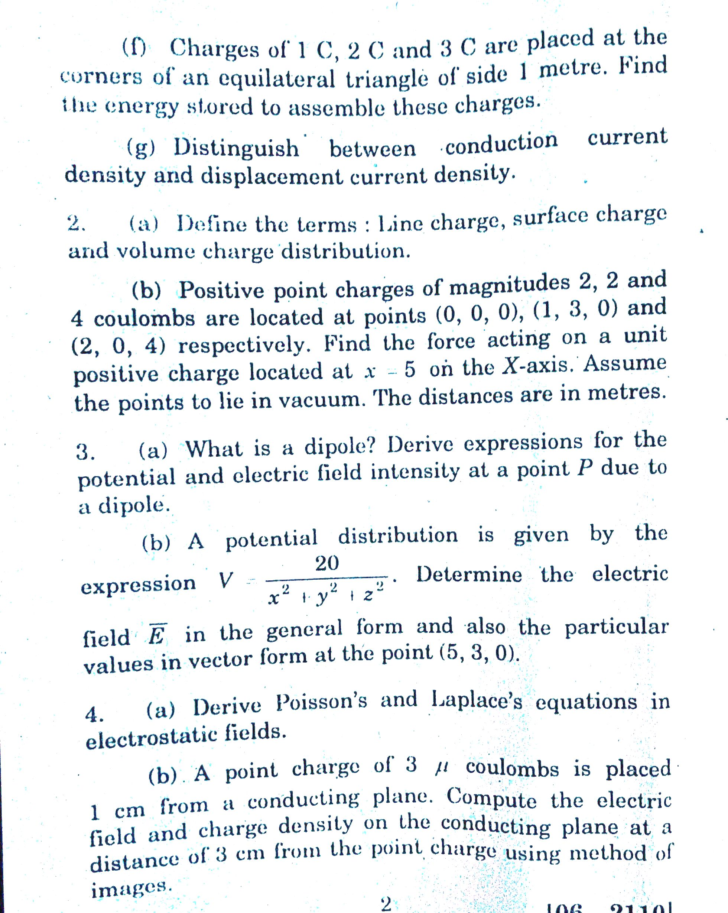
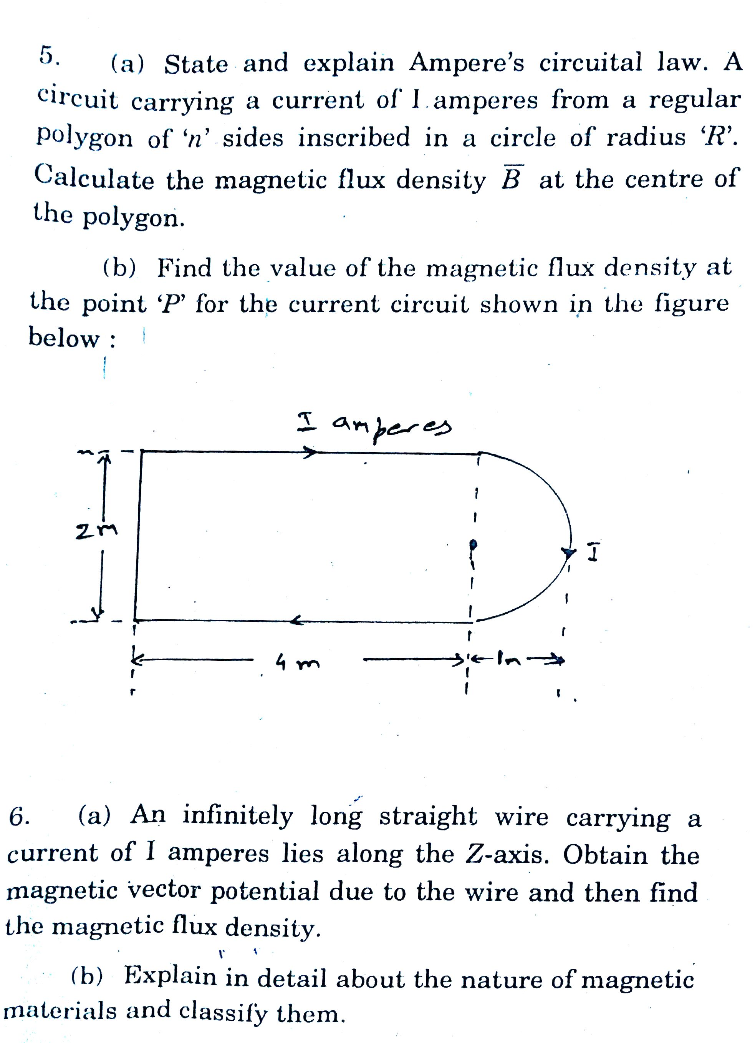
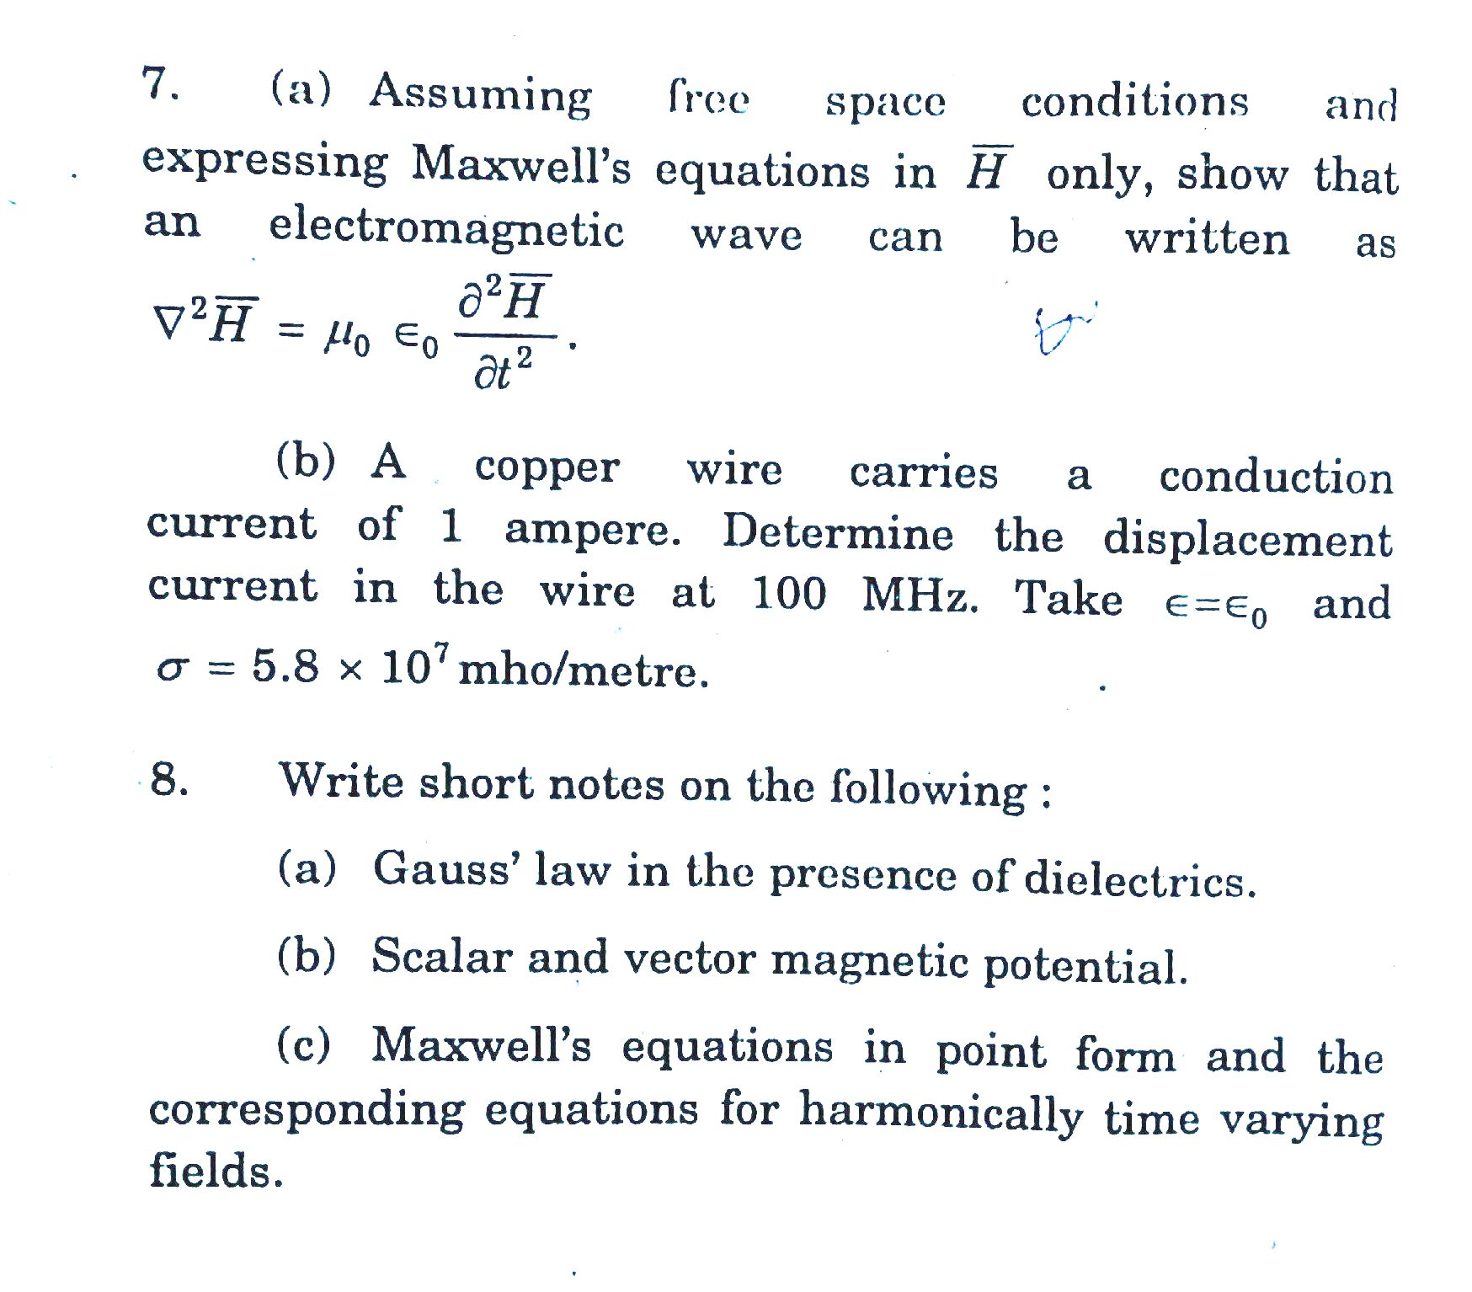
Batch II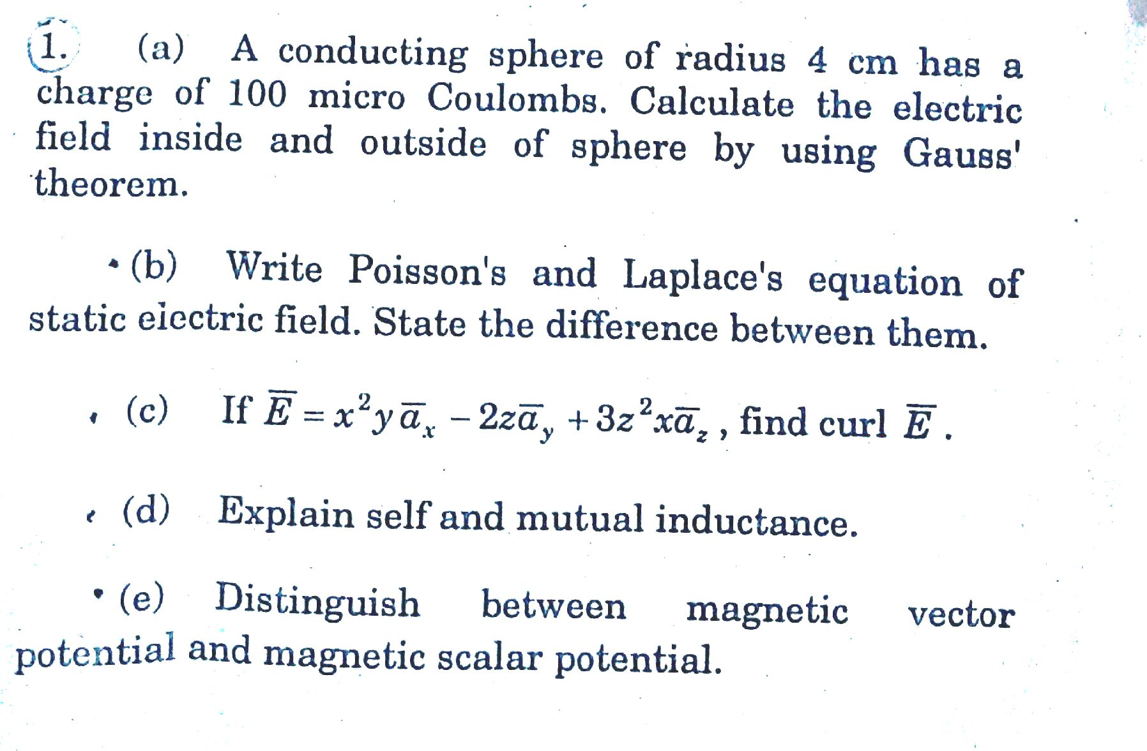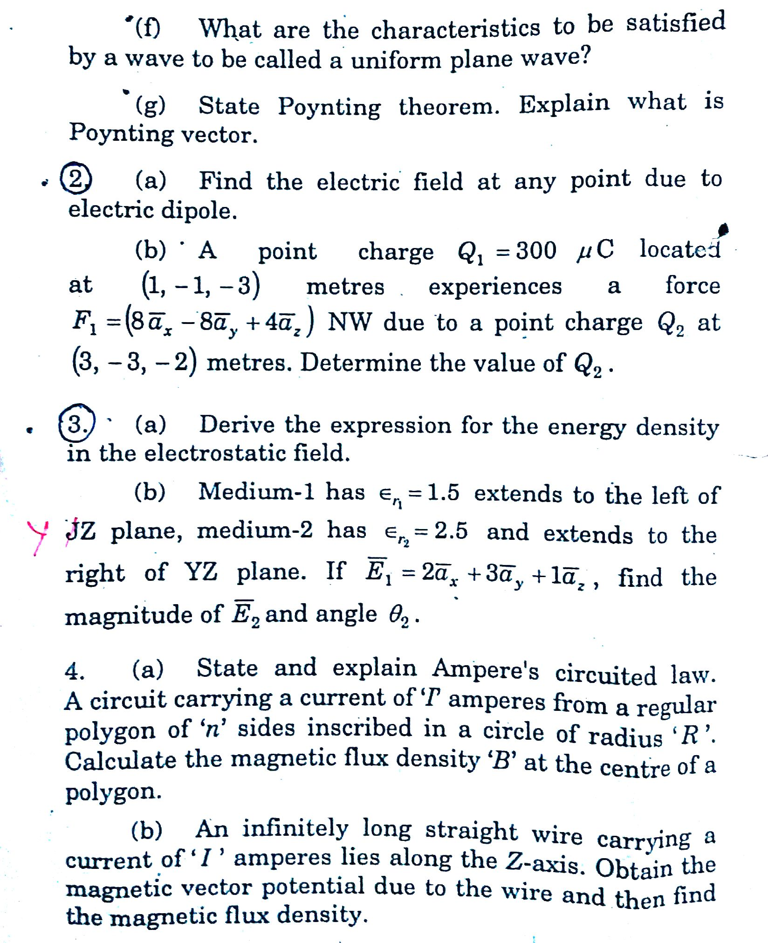
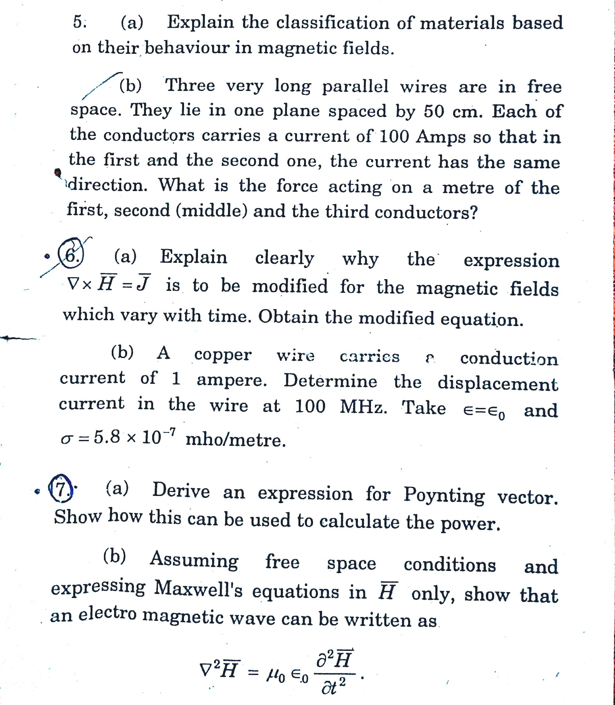
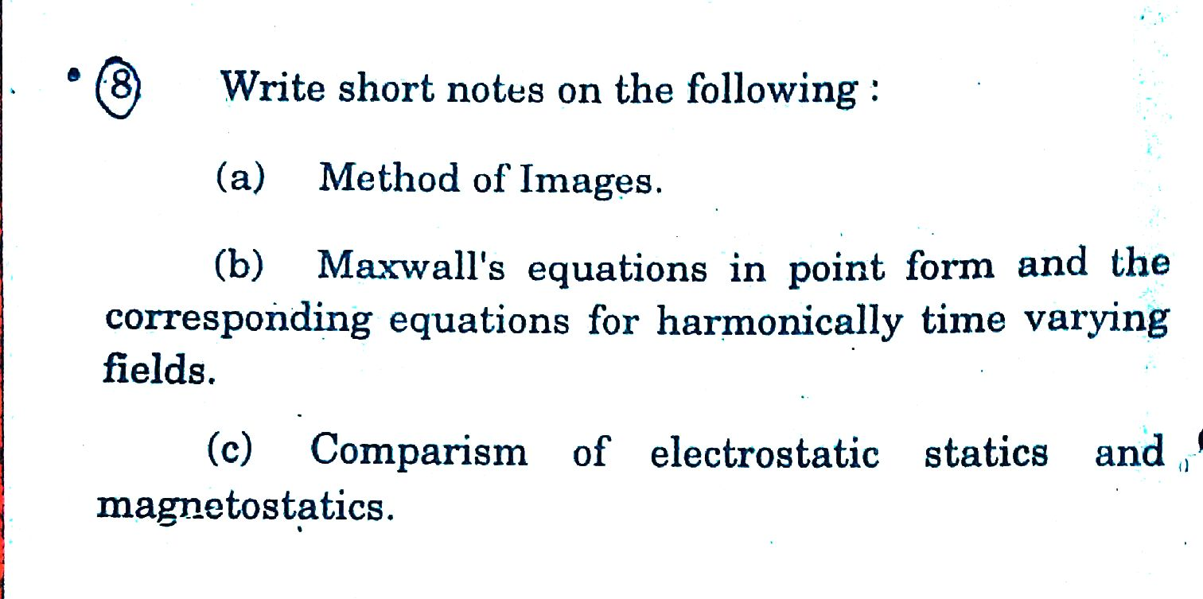
Batch III

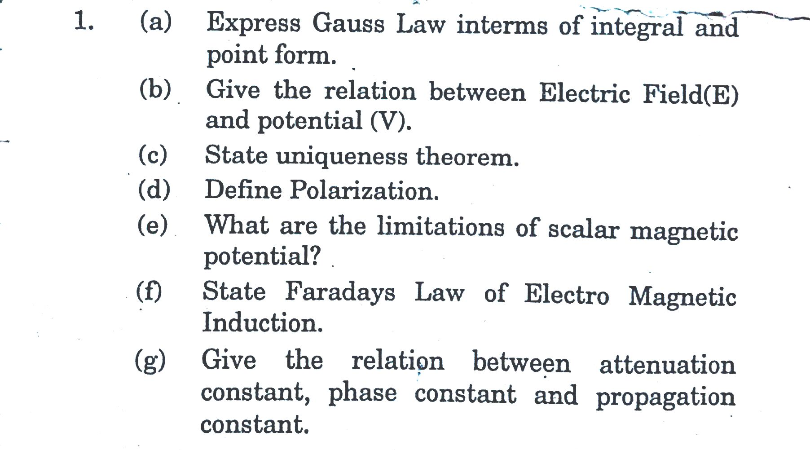

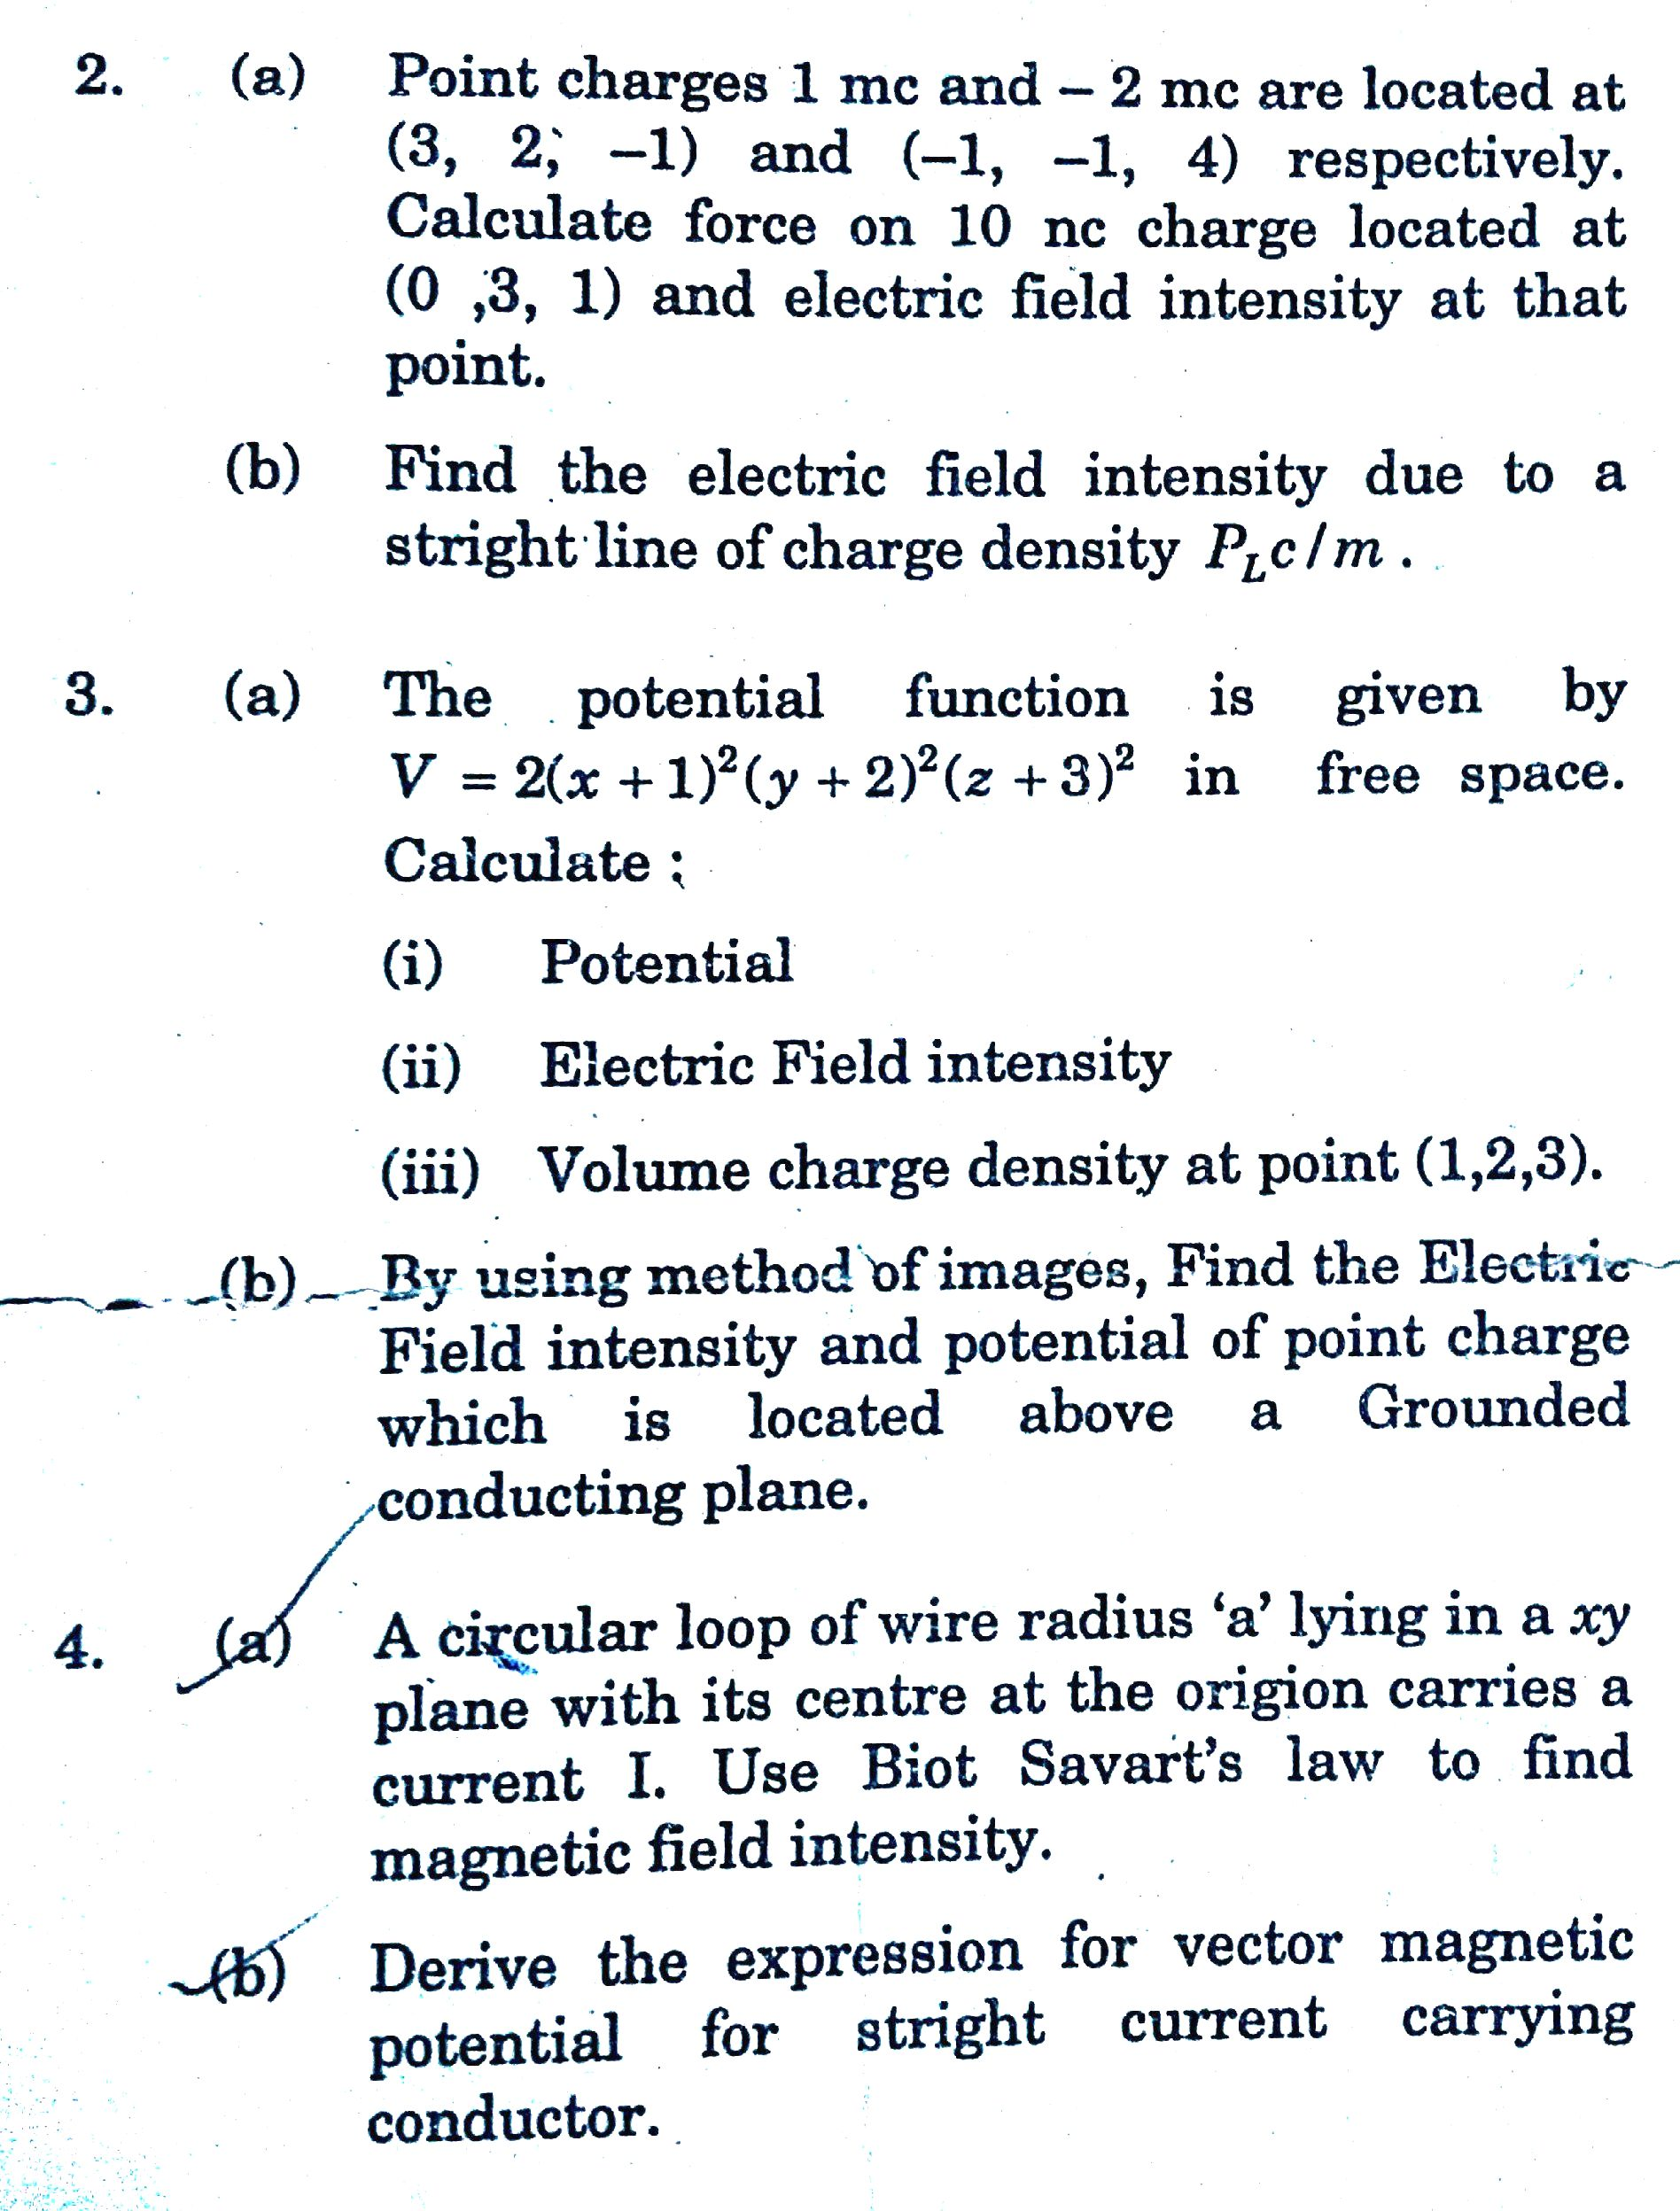

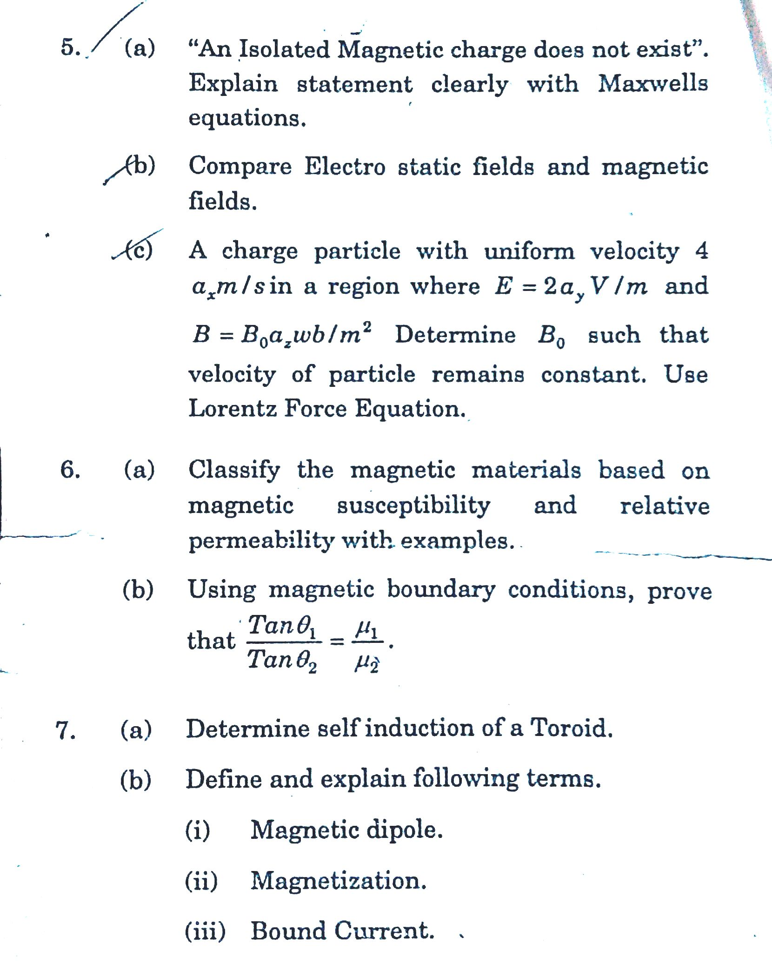

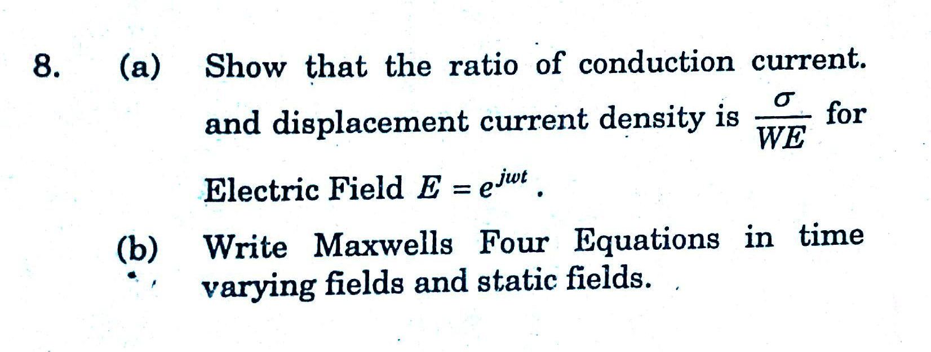
Batch IV

Batch V

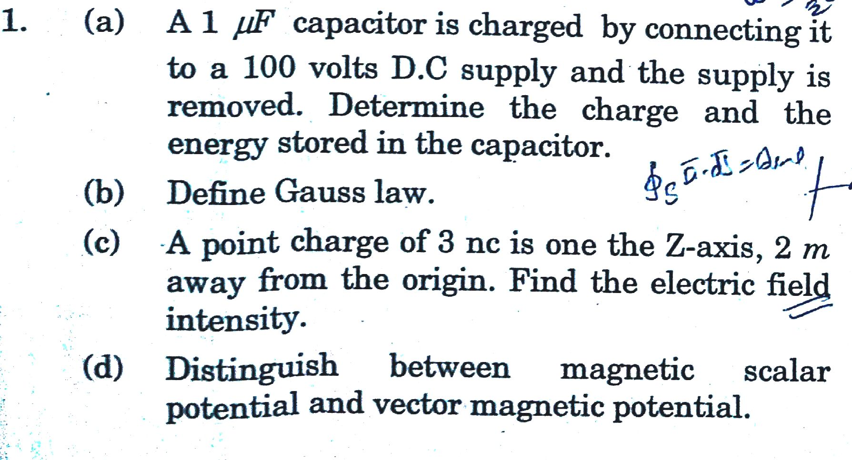

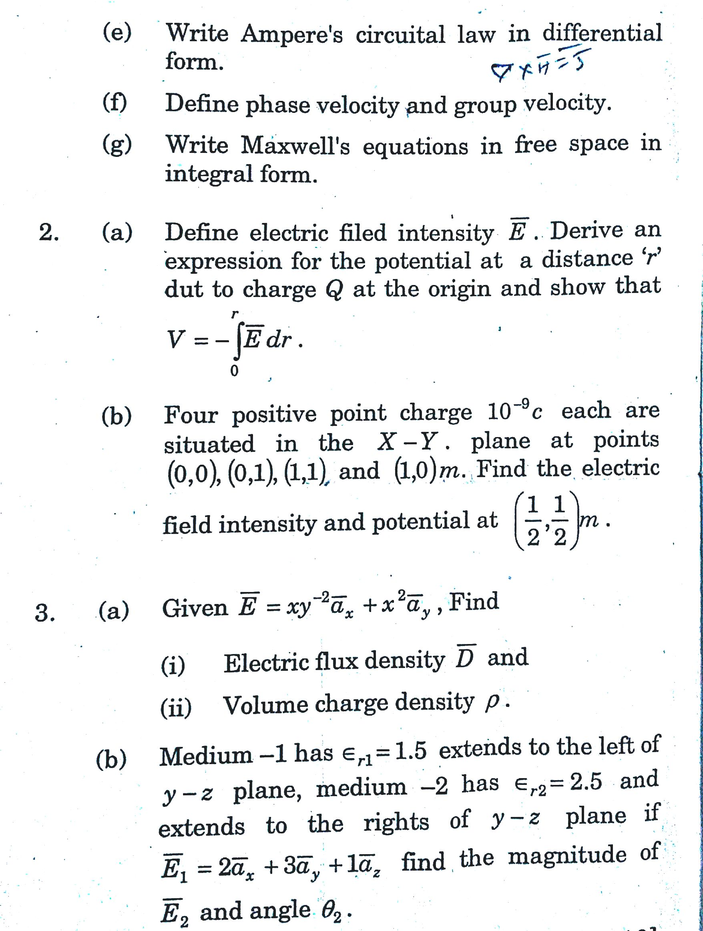

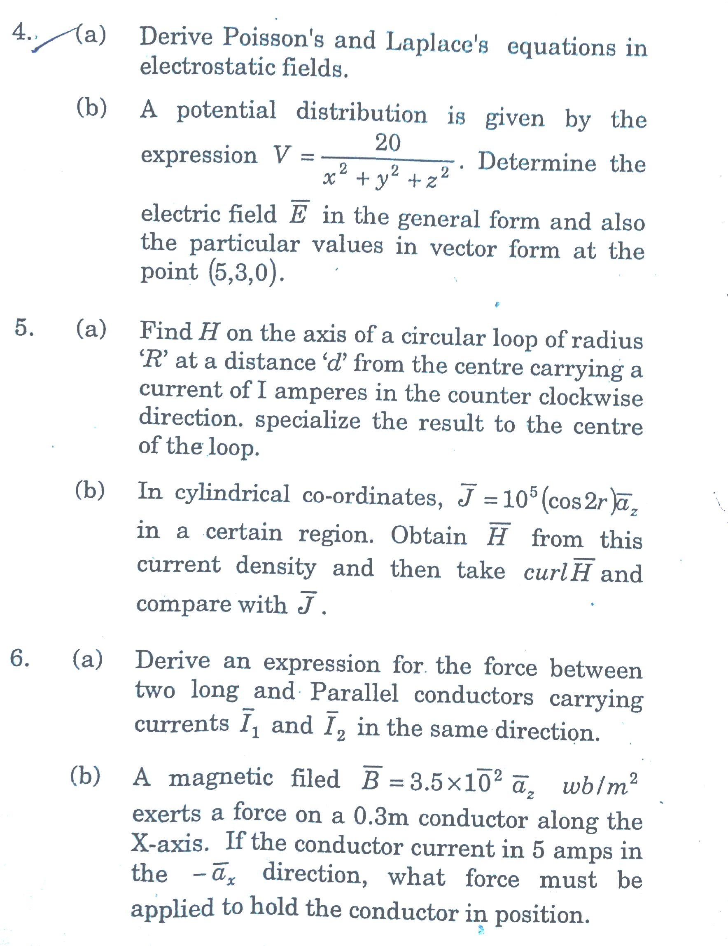

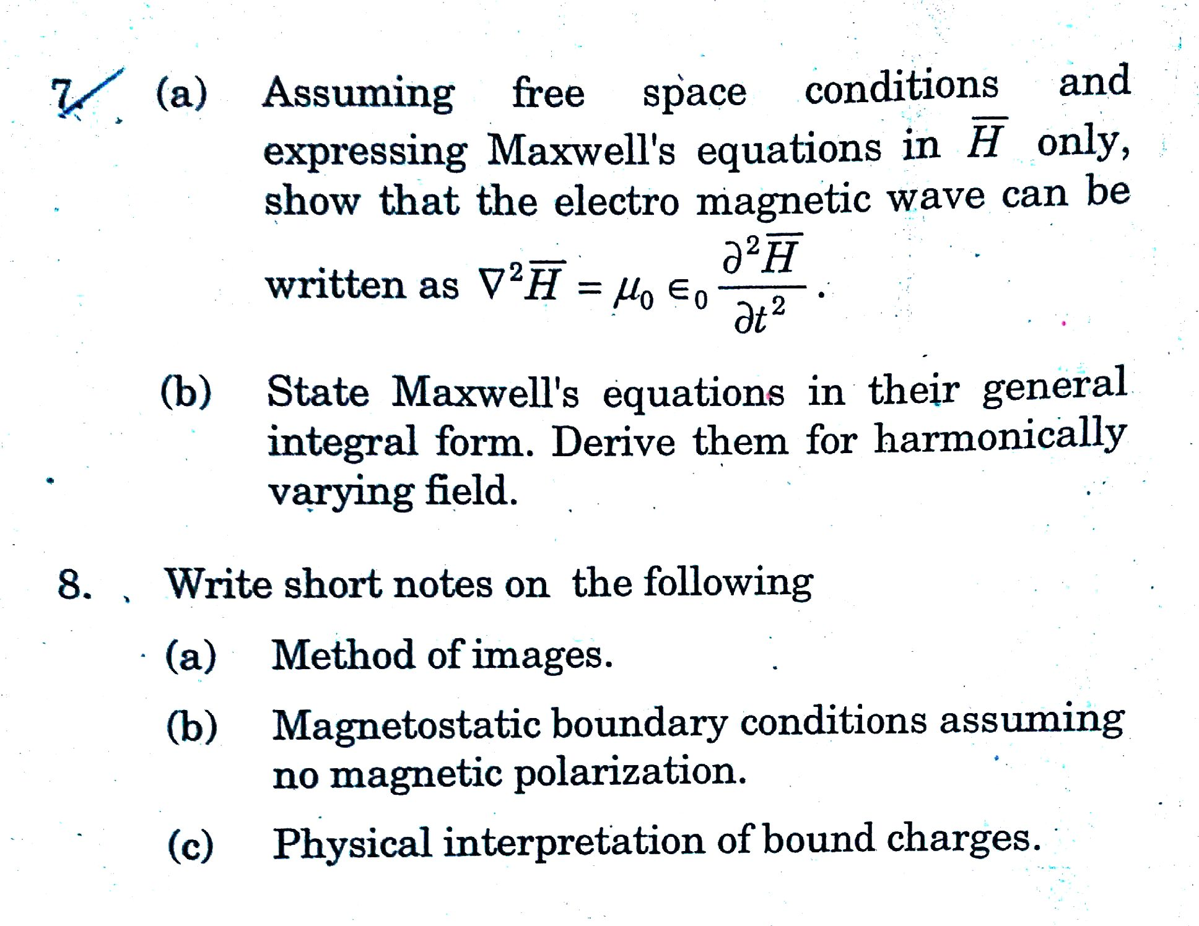

Batch VI



