SIR C.R.REDDY COLLEGE OF ENGINEERING, ELURU
DEPARTMENT OF MECHANICAL ENGINEERING

ENGINEERING THERMODYNAMICS-III
Model Short Answer Questions And Answers

INTERNAL COMBUSTION ENGINES

1. What is an internal combustion engine?
Ans.:-Internal combustion engines Is an engine in which the combustion of fuel takes place inside the engine cylinder. These are petrol, diesel and gas engines.
2. What is the function of piston rings?
Ans.:-There are two sets of piston rings mounted for the piston. The function of upper rings is to provide air tight seal to prevent leakage of the burnt gases in to lower portion.
The function of the lower rings is to provide effective seal to prevent leakage of the oil into the engine cylinder.
3. Function of Fly wheel?
Ans.:-The function of Fly wheel is to store energy during power stroke and return during other strokes and there by maintain constant speed.
4. What is valve timing diagram?
Ans.:-A valve timing diagram is a graphical representation of the exact moments, in the sequence of operations, at which the two valves (inlet and exhaust valves) open and close as well as firing of the fuel. It is generally expressed in terms of angular positions of the crankshaft.
5. What is Clearance volume, Stroke volume and Compression ratio?
Ans.:-Clearance volume: The space between cylinder head and piston when the piston is at the top dead center is known as clearance volume.
Stroke volume: The volume displaced by the piston as it moves from one dead center to the other dead center is called stroke volume (swept volume).
Compression ratio: The ratio of total cylinder volume (stroke volume + clearance volume) to the clearance volume
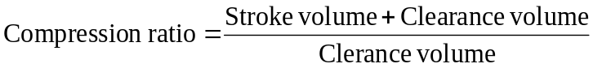

6. What are the functions of Fuel injection system for C.I. engines?
Ans.:-
- To meter (measure) the correct quantity of fuel to be injected
- Atomize the fuel in to fine particles
- Time the fuel injection
- Control the rate of fuel injection
- Properly distribute the fuel in the combustion chamber
7. Differentiate between Air injection system and Airless (solid) injection system?
Ans.:-
Air injection system | Air less (solid) injection system
1. Liquid fuel is sprayed into the engine cylinder by means of compressed air | 1. Liquid fuel is injected into the engine cylinder at high pressure by means of fuel pump.
2. It requires multi stage air compressor which causes increases in engine weight and reduce net power output. It is used rarely. | 2. This system is used more common.
8. What is carburettor?
Ans.:-The process of atomizing the fuel and mixing of fuel with air at required proportion for SI engines is called carburetion and the device in which this process takes place is called carburettor.
9. Differentiate between air cooling system and water-cooling system?
Ans.:-
Air cooling system | Water cooling system
The design of this system is simple and less costly. | The design of this system is complex and more costly.
The mass of the cooling system is very less. | The mass of the cooling system is very much more.
The fuel consumption is more. | The fuel consumption is less.
Its installation and maintenance is very easy and less costly. | Its installation and maintenance is very difficult and more costly.
There is no danger of leaking or freezing of the coolant. | There is a danger of leaking or freezing of the coolant.
It doesn’t require any coolant. | It requires coolant.
10. What are the functions of carburettor?
Ans.:-
- To maintain a small reserve of petrol at a constant level in float chamber.
- To atomize the liquid fuel (petrol) and to mix it with air
- To supply air-fuel vapour mixture at correct ratio according to engine requirements.
11. What are the differences between a carburettor and fuel injector?
Ans.:-
Carburettor | Fuel injector
1. Carburettor is used in spark ignition system. | 1. Fuel injector is used in compression ignition system.
2. Carburettor supply Fuel + air mixture in to the engine cylinder. | 2. Fuel injector supply only fuel in to the engine cylinder.
12. What is scavenging?
Ans.:-The process of removing burnt gases, from the combustion chamber of the engine cylinder is defined as scavenging.
13. What is the purpose of spark plug?
Ans.:-The purpose of spark plug is to conduct spark into combustion chamber due to which the ignition of air fuel mixture takes place.
14. Write about performance parameters of IC engine?
Ans.:-Indicated Power (I.P): The power produced inside the engine cylinder is called indicated power.
Brake power (B.P): The power output of the engine at the crank shaft is called brake power. It is also called shaft power.
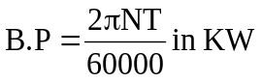
T = (w – s) R_{m}
N = speed in rpm
Friction Power (F.P): The difference between indicated power and brake power. It is the power wasted due to friction at the bearings and sliding parts
F.P = I.P – B.P
Mechanical efficiency: It is the ratio of brake power to the indicated power. It is denoted by η_{m}
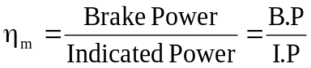
Brake thermal efficiency: It is defined as the ratio of heat utilized to produce brake power to heat supplied. It is denoted by η_{b}

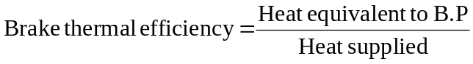
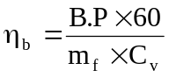
m_{f} = mass of fuel supplied per min, in kg/min
C_{v} = calorific value of fuel, kg/kg
Indicated thermal efficiency: It is defined as the ratio of heat utilized to produce indicated power to heat supplied. It is denoted as η_{i}
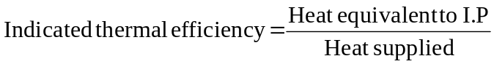
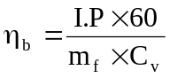
Indicated mean effective pressure (IMEP): It is defined as hypothetical pressure which is thought to be acting on the piston through out the power stroke and based on indicated power.
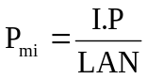
Brake thermal effective pressure (BMEP): It is defined as hypothetical pressure which is thought to be acting on the piston through out the power stroke and based on brake power.
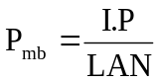
Specific heat consumption (SFC): It is the mass of fuel consumed per KW developed per hour.
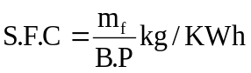

15. What is angle of overlap?
Ans.:-It is the crank angle during which the exhaust valve remains open during the suction period i.e. the angle between inlet valve open (I.V.O) and exhaust valve close (E.V.C).

16. What is indicator diagram?
Ans.:-An “indicator diagram” is a graph between pressure and volume the former being taken on vertical axis and the latter on the horizontal axis. This is obtained by an instrument known as indicator

17. What is supercharging?
Ans.:-The apparatus used to increase the air density is known as a supercharger. It is merely a compressor which provides a denser charge to the engine, thereby enabling the consumption of a greater mass of charge with the same total piston displacement. The purpose of supercharging is to raise the volumetric efficiency above that value which can be obtained by normal aspiration.
The schematic arrangement for supercharging SI. engine
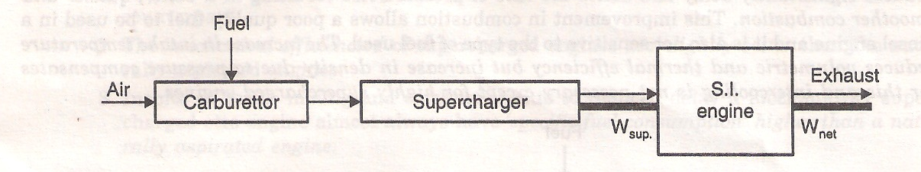
18)What are the methods for Measurement of frictional power ?
Ans.:-The frictional power of an engine can be determined by the following methods
1, Willan’s line method (used for CI. engines only)2, Morse test3. Motoring test
4. Difference between I.P. and B.P.5.Retardation test
19)what is air standard efficiency?
Ans.:- The efficiency of engine using air as the working medium is known as air standard efficiency.
20) What is The mean effective pressure of the cycle ?
Ans.:- Mean effective pressure (P_{m}) of the cycle is the ratio of Work done per cycle to Stroke volume
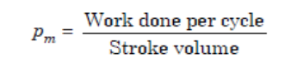
21) What are the differences between Flywheel and Governor?
Ans.:-
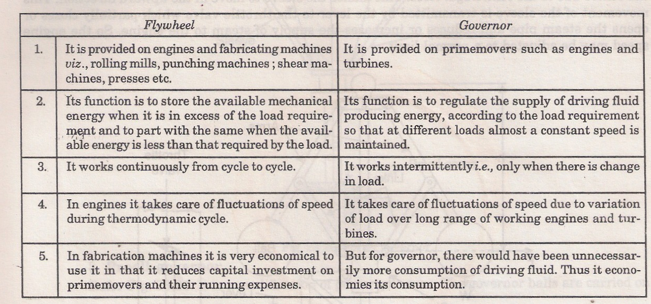
22) Classify Internal combustion engines?
Ans.:-Internal combustion engines may be classified as given below:
1. According to cycle of operation:
(1) Two-stroke cycle engines (ii) Four-stroke cycle engines.
2. According to cycle of combustion:
(i) Otto cycle engine (ii) Diesel cycle engine (iii) Dual-combustion or Semi-Diesel cycle engine 3. According to arrangement of cylinder:
(i) Horizontal engine (ii) Vertical engine(iii) V-type engine (iv) Radial engine etc.
4. According to their uses:
(i) Stationary engine (ii) Portable engine(iii) Marine engine (iv) Automobile engine(v) Aero engine etc.
5. According to the fuel employed and the method of fuel supply to the engine cylinder:
(i) Oil engine (ii) Petrol engine(iii) Gas engine (iv) Kerosene engine(v) Carburettor, hot bulb, solid injection and air injection engine.
6. According to the speed of the engine:
(i) Low speed engine (ii) Medium speed engine(iii) High speed engine.
7. According to method of ignition:
(i) Spark ignition (S.I.) engine (ii) Compression ignition (C.I.) engine.
8. According to method of cooling the cylinder:
(i) Air-cooled engine (ii) Water-cooled engine.
9. According to method of Governing:
(i) Hit and miss governed engine (ii) Quality governed engine(iii) Quantity governed engine.
10. According to valve arrangement:
(i) Overhead valve engine (ii) L-head type engine(iii) T-head type engine (iv) F-head type engine.
11. According to number of cylinders:
(i) Single cylinder engine (ii) Multi-cylinder engine.
23) List the applications of I.C. engines?
Ans.:-The I.C. engines are generally used for:
(i) Road vehicles (e.g., scooter, motorcycle, buses etc.)(ii) Air craft(iii) Locomotives(iv) Construction in civil engineering equipment such as bull-dozer, scraper, power shovels etc.(v) Pumping sets(vi) Cinemas(vii) Hospital(viii) Several industrial applications.

COMBUSTION
1) What is flame front?
Ans.:-The flame front is a narrow zone separating the fresh mixture from the combustion products. The velocity with which the flame front moves, with respect to the unburned mixture in a direction normal to its surface is called the normal flame velocity.
2) What is equivalence ratio?
Ans.:-Equivalence ratio is the ratio of the actual fuel-air ratio to the stoichiometric fuel-air ratio
3) What are the terms homogeneous gas mixture and heterogeneous gas mixture ?
Ans.:-In a homogeneous gas mixture the fuel and oxygen molecules are more or less, uniformly distributed.
In a heterogeneous gas mixture, the fuel and oxygen molecules are not distributed uniformly
4) What are the Knock Limited Parameters?
Ans.:-Knock Limited Compression Ratio: The knock limited compression ratio is obtained by increasing the compression ratio of a variable compression ratio engine until incipient knocking is observed.
Knock Limited Inlet Pressure: The inlet pressure can be increased by opening the throttle or increasing supercharger deliver pressure until the incipient knock is observed.
Knock Limited Indicated Mean Effective Pressure: The indicated mean effective pressure measured at incipient knock is usually abbreviated as Klimep. This parameter and the corresponding fuel consumption are obviously of great practical interest.
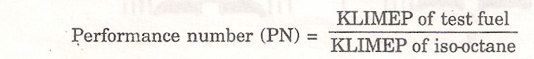
Highest Useful Compression Ratio (HUCR)
The highest useful compression ratio is the highest compression ratio employed at which a fuel can be used in a specified engine under specified set of operating conditions, at which detonation first becomes audible with both the ignition and mixture strength adjusted to give the highest efficiency.
Relative performance number, rpn, which is defined as:
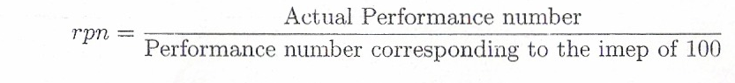
5) What is the self ignition temperature?
Ans.:-The self ignition temperature (S.I.T.) is the temperature at which the fuel ignites and continues to burn without the need of a flame to initiate the burning.
6) What is ignition lag in SI Engine?
Ans.:-The time lag between first igniting of fuel and the commencement of the main phase of combustion is called the period of incubation or is also known as ignition lag.
7) What are the terms Ignition delay period, Physical delay and Chemical delay in CI engine?
Ans.:-Ignition delay period in CI engine is counted from the start of injection to the point where the pressure-crank angle curve separates from the motoring curve indicated as start of combustion.
Physical delay: The Physical delay is the time between the beginning of injection and the attainment of chemical reaction conditions
Chemical delay : During the Chemical delay, reactions start slowly and then accelerate until inflammation or ignition takes place.
8)What is combustion process ?
Ans.:-According to Ricardo, the combustion process can be imagined as if developing in two stages, one the growth and development of a self-propagating nucleus of flame (ignition lag), and the other the spread of that flame throughout the combustion chamber.
9)What is detonation.
Ans.:-A very sudden rise of pressure during combustion accompanied by metallic hammer like sound is called detonation.
10)What is the significance of delay period in CI engine?
Ans.:-The delay period exerts a great influence in the C.I. engine combustion phenomenon. It is clear that the pressure reached during the second stage will depend upon the duration of the delay period .
The longer the delay, the more rapid and higher the pressure rise. This causes rough running and may cause diesel knock. Therefore we must aim to keep the delay period as short as possible, both for the sake of smooth running and in order to maintain control over the pressure changes. But some delay period is necessary otherwise the droplets would not be dispersed in the air for complete combustion.
11) What are the theories of detonation?
Ans.:-There are two general theories of knocking/detonation
(i) The auto-ignition theory
(ii) The detonation theory.
(i) Auto-ignition theory. Auto-ignition refers to initiation of combustion without the necessity of a flame. The auto-ignition theory of knock assumes that the flame velocity is normal before the onset-of auto-ignition and that gas vibrations are created by a number of end-gas elements auto-igniting almost simultaneously.
(ii) Detonation theory. In the auto-ignition theory, it is assumed that the flame velocity is normal before the onset of auto-ignition whereas in detonation theory a true detonating wave formed by
pre-flame reactions has been proposed as the Mechanism for explosive auto-ignition. Such a shock wave would travel through the chamber at about twice the sonic velocity and would compress the gases to pressures and temperatures where the reaction should be practically instantaneous.
12)What are the Effects of detonation
Ans.:-1. Noise and roughness 2. Mechanical damage 3. Carbon deposits.
4. Increase in heat transfer 5. Decrease in power output and efficiency 6. Pre-ignition.
13) What are the methods to Control of detonation in SI engine? -
Ans.:-The detonation can be controlled or even stopped by the following methods
1. Increasing engine r.p.m. 2. Retarding spark. 3, Reducing pressure in the inlet manifold by throttling.
4. Making the ratio too lean or too rich, preferably latter.
5. Water injection. Water injection increases the delay period as well as reduces the flame temperature.
6. Use of high octane fuel can eliminate detonation. High octane fuels are obtained by adding additives known as dopes (such as tetra-ethyl of lead, benzol, xylene etc.), to petrol.
14)What is pre-ignition.
Ans.:-The premature combustion which starts before application of spark in Si engine is called
pre-ignition.
15)What are the terms octane number and Cetane number of fuel?
Ans.:-The fuel under test is compared with a mixture of iso-octane (high rating) and normal heptane (low rating), by volume. The octane number of the fuel is the percentage of octane in the reference mixture which knocks under the same conditions as the fuel.
CETANE NUMBER
The procedure for obtaining Cetane number is similar to that for obtaining the octane number of petrol. Reference mixtures of Cetane (C16H34) (high ignitability), and a-methylnaphthalene (C11H10) (low ignitability), are used. The mixture is made by volume and the ignitability of the test fuel is quoted as the percentage of Cetane in the reference mixture which has the same ignitability.
16)What is the significance of Turbulence?
Ans.:-Significance of Turbulence
Turbulence plays a very important role in combustion phenomenon in S.I. (as well CI.) engines. The flame speed is very low in non-turbulent mixtures. A turbulent motion of the mixture intensifies the processes of heat transfer and mixing of the burned and unburned portions in the flame front (diffusion). These two factors cause the velocity of turbulent flame to increase practically in proportion to the turbulent velocity. The turbulence of the mixture is due to admission of fuel-air mixture through comparatively narrow sections of the intake pipe, valves etc., in the suction stroke.
17)What are the terms Swirl, Squish and Tumble?
Ans.:- The main macro mass motion within the cylinder is rotational motion and is called swirl. It is generated by constructing the intake system to give a tangential component to the intake flow as it enters the cylinder. This is done by shaping and contouring the intake manifold, valve ports and even the piston face.
This radial inward motion of the gas mixture is called “squish’ It adds to other mass motions within the cylinder to mix the air and fuel and to quickly spread the flame front
As the piston nears T.D.C. squish motion generates a secondary rotational flow called “tumble”. This rotation occurs about a circumferential axis near the outer edge of the piston bowl.
18) What are the different phases of combustion in SI and CI engines?
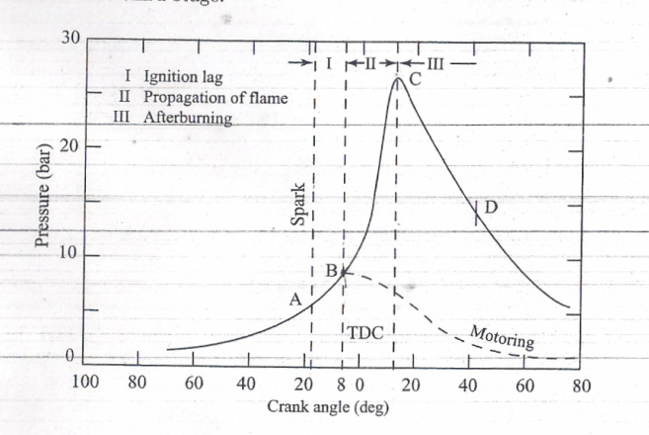
Ans.:-
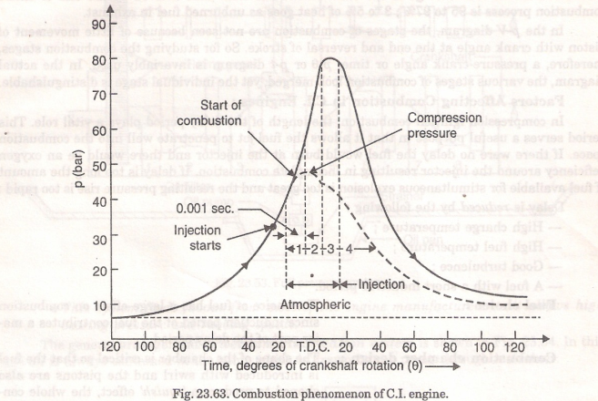

Three phases of combustion in SI engine Four phases of combustion in CI engine
1. Ignition lag 1. Ignition delay period.
2. Propagation of flame 2. Period of rapid or uncontrolled combustion.
3. After burning 3. Period of controlled combustion.
4. After burning

AIR COMPRESSORS
1) What is the function of a compressor?
Ans.:-The function of a compressor is to take a definite quantity of fluid (usually gas, and most often air) and deliver it at a required pressure.
2) What are the applications of compressed air?
Ans.:-The compressed air finds application in the following fields:
1. It is widely employed for powering small engines, generally those of portable nature. Compressed air is used in such diversified fields as:
(i) Operating tools in factories;
(ii) Operating drills and hammers in road building;
(iii) Excavating;
(iv) Tunneling and mining;
(v) Starting diesel engines; and
(vi) Operating brakes on buses, trucks and trains.
2. A large quantity of air at moderate pressure is used in smelting of various metals such as melting iron, in blowing converters, and cupola work.
3. Large quantities of air are used in the air-conditioning, drying, and ventilation fields
3) Classify compressors?
Ans.:-Air and gas compressors are classified into two main types:
1. Reciprocating compressors; and
2. Rotary compressors.
— According to whether or not the process of compressing is carried out in one unit or in several similar units in the one machine, a compressor may be single stage, or multistage.
— Again, in case of reciprocating compressors, the air maybe compressed in the cylinder on one side of the piston only, or use maybe made of both piston faces. Such compressors are single-acting and double acting, respectively.
— Centrifugal compressors, which are of the rotary type, may be single or double entry, which means that the compressor is filled with either one or two air intakes according to whether it is of the former or latter type when compression takes place in one or two units, respectively.
Air compressors maybe classified in another manner, this time from an aspect of the use to which they are put.
— For example, air pumps and exhausters are used to produce vacuum, their job being to remove air from a particular system to create a low pressure therein.
— Blowers and superchargers are essentially air compressors, but the increase in pressure which they produce is only small, and up to, say 0.7 to 1.05 bar.
— A booster is an air or gas compressor which is employed to raise the pressure of air/gas which has already been compressed. It is where a slightly higher pressure is required, or where a loss of pressure has occurred in a long delivery line.
4) Define isothermal efficiency and Volumetric Efficiency?
Ans.:-For a reciprocating compressor, a comparison between the actual work done during compression and the ideal isothermal work done is made by means of the isothermal efficiency.

The volumetric efficiency of a compressor is the ratio of free air delivered to the displacement of the compressor. It is also the ratio of effective swept volume to the swept volume.

5) What are advantages of multistage compression?
Ans.:-The advantages of multistage compression are
1. The air can be cooled at pressures intermediate between intake and delivery pressures.
2. The power required to drive a multistage machine is less than would be required by a single-stage machine delivering the same quantity of air at the same delivery pressure.
3. Multistage machines have better mechanical balance.
4. The pressure range (and hence also the temperature range) maybe kept within desirable limits. This results in (i) reduced losses due to air leakage (ii) improved lubrication. due to ‘[lower temperatures and (iii) improved volumetric efficiency.
5. The cylinder, in a single-stage machine, must be robust enough to withstand the delivery pressure. The down pressure cylinders of a multistage machine may be lighter in construction since the maximum pressure there in is low.
Disadvantages:
Inspite of all these advantages, a multistage compressor with intercoolers is likely to be more expensive in initial cost than a single-stage compressor of the same capacity.
6) Define compressor efficiency, isothermal efficiency, adiabatic efficiency and Mechanical efficiency?
Ans.:-


The ‘adiabatic efficiency’ of an air compressor is the ratio of’ the horse power required to drive the compressor compared with the area of the hypothetical indicator diagram assuming adiabatic compression.
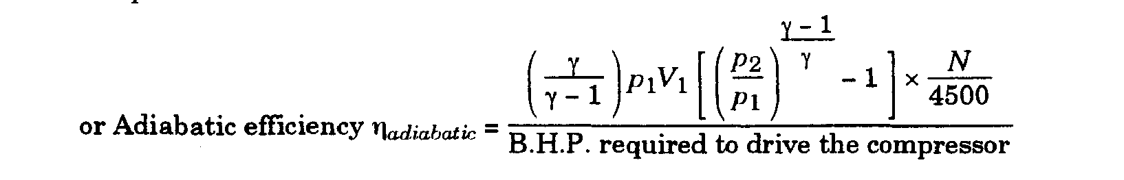
Mechanical efficiency. In general, the mechanical efficiency is the ratio of the mechanical output to the mechanical input. For an air compressor,

7) How to increase Isothermal Efficiency?
Ans.:-The following methods are employed to achieve nearly isothermal compression for high speed compressors:
(1) Spray injection (2) Water jacketing. (3) Inter-cooling. (4) External fins.
(5) By a suitable choice of cylinder proportions
8) Define Free Air Delivered (F.A.D.) and Displacement?
Ans.:-The free air delivered (F.A.D.) is the actual volume delivered at the stated pressure reduced to intake temperature and pressure, and expressed in m³/min.
The displacement is the actual volume in m/min swept out per minute by the L.P. piston or pistons during the suction strokes.
The free air delivered per minute is less than the displacement of the compressor because of the following reasons:
1. The fluid resistance through the air intake, and valves prevents the cylinder being fully charged with air at atmospheric conditions.
-2. On entering the hot cylinder the air expands
3. The high-pressure air trapped in the clearance space, must expand to a pressure below atmospheric before the automatic suction valves can open ; a portion of the suction stroke is therefore wasted in effecting this expansion.
4. A certain loss is caused by the leakage.

9) Classify rotary compressors?
Ans.:-Whenever large quantities of air or gas are required at relatively low pressure rotary compressors are employed.
They are classified as follows:
1. Displacement compressors
(a) Roots blower (b) Sliding vane compressors
2. Steady-flow compressors
(a) Centrifugal compressor (b) Axial flow compressor.
10)What are the Positive Displacement Compressors and Steady flow compressors?
Ans.:- Positive Displacement Compressors are those compressors in which air is compressed by being trapped in the reduced space formed by two sets of engaging surfaces.
Steady flow compressors are those compressors in which compression occurs by transfer of kinetic energy from a rotor.
11) Define Isentropic Efficiency of the Compressor?
Ans.:-
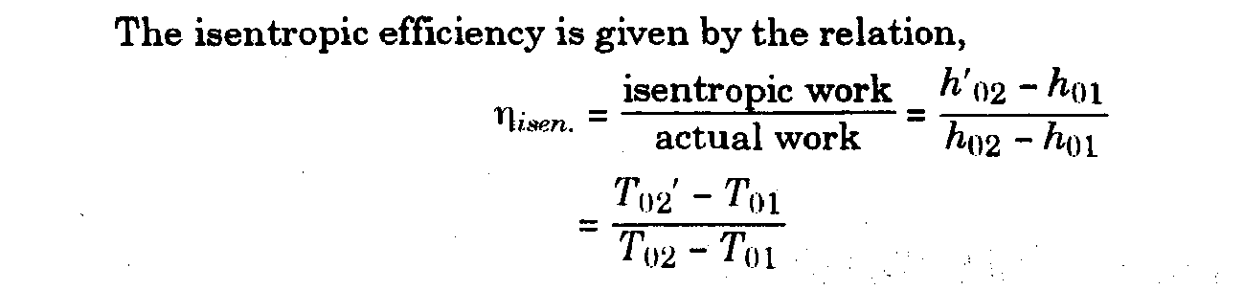
12) Define Slip factor, Pressure Co-efficient and degree of reaction?
Ans.:-
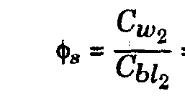

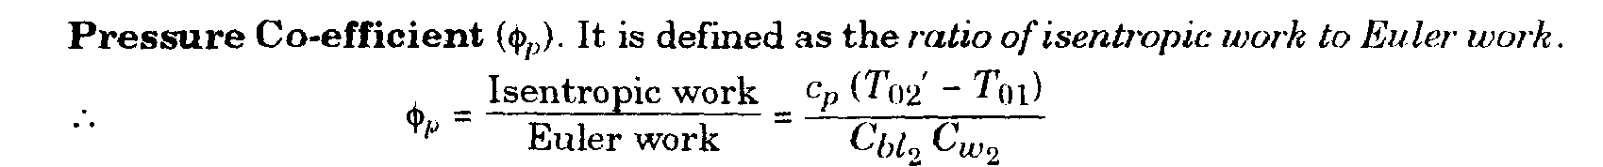
13) Define Surging and Choking?
Ans.:-
In the compressor where the flow is against the pressure gradient, the incidence loss due to incorrect fluid angles relative to the blades becomes more important and pressure ratio falls sharply at conditions away from the design point. This loss, added to the friction loss, which will increase with increase of mass flow rate, gives a pressure ratio-mass flow rate relation as shown in Fig.
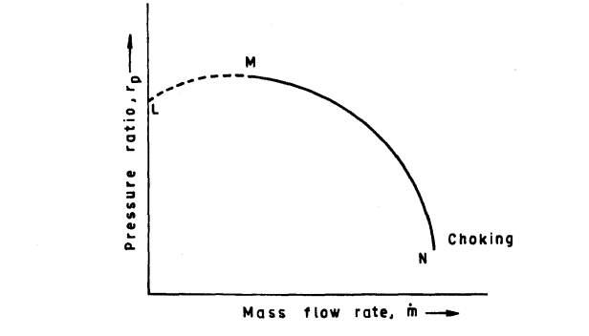
- At point N, the compressor is choked and is passing the maximum mass flow rate.
- On the section MN of the curve the flow is stable. A fall in mass flow rate will result in a rise in pressure ratio which will tend to restore the fall.
- On the section LM of the curve, the flow is not stable. A fall in mass flow rate will be accompanied by a fall in pressure ratio. In this situation any small disturbance causing a cheek in mass flow will cause a fall in pressure ratio and the flow may reverse at some point. When the temporary disturbance is removed, the flow will pick up and it is found that small disturbances cause the flow to oscillate rapidly. The oscillations are noisy and can, if allowed to continue, cause structural damage in the compressor. It is called ‘surge’ and the point M on the curve marks the limit of useful operation of the compressor.
14) Compare reciprocating and rotary air compressors?
Ans.:-comparison between reciprocating and rotary air compressors
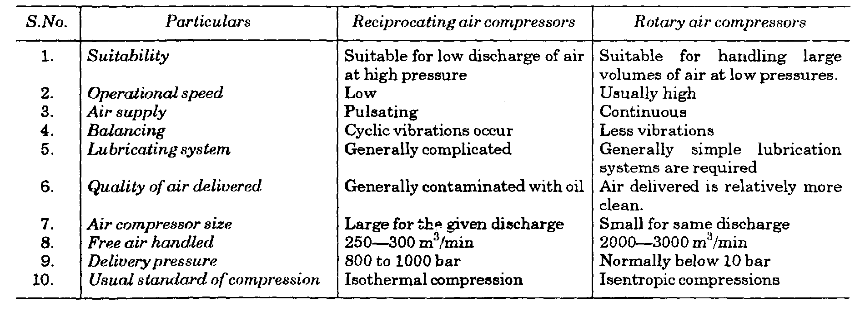
15) Compare axial flow and centrifugal compressors?
Ans.:-Comparison between axial flow and centrifugal compressors
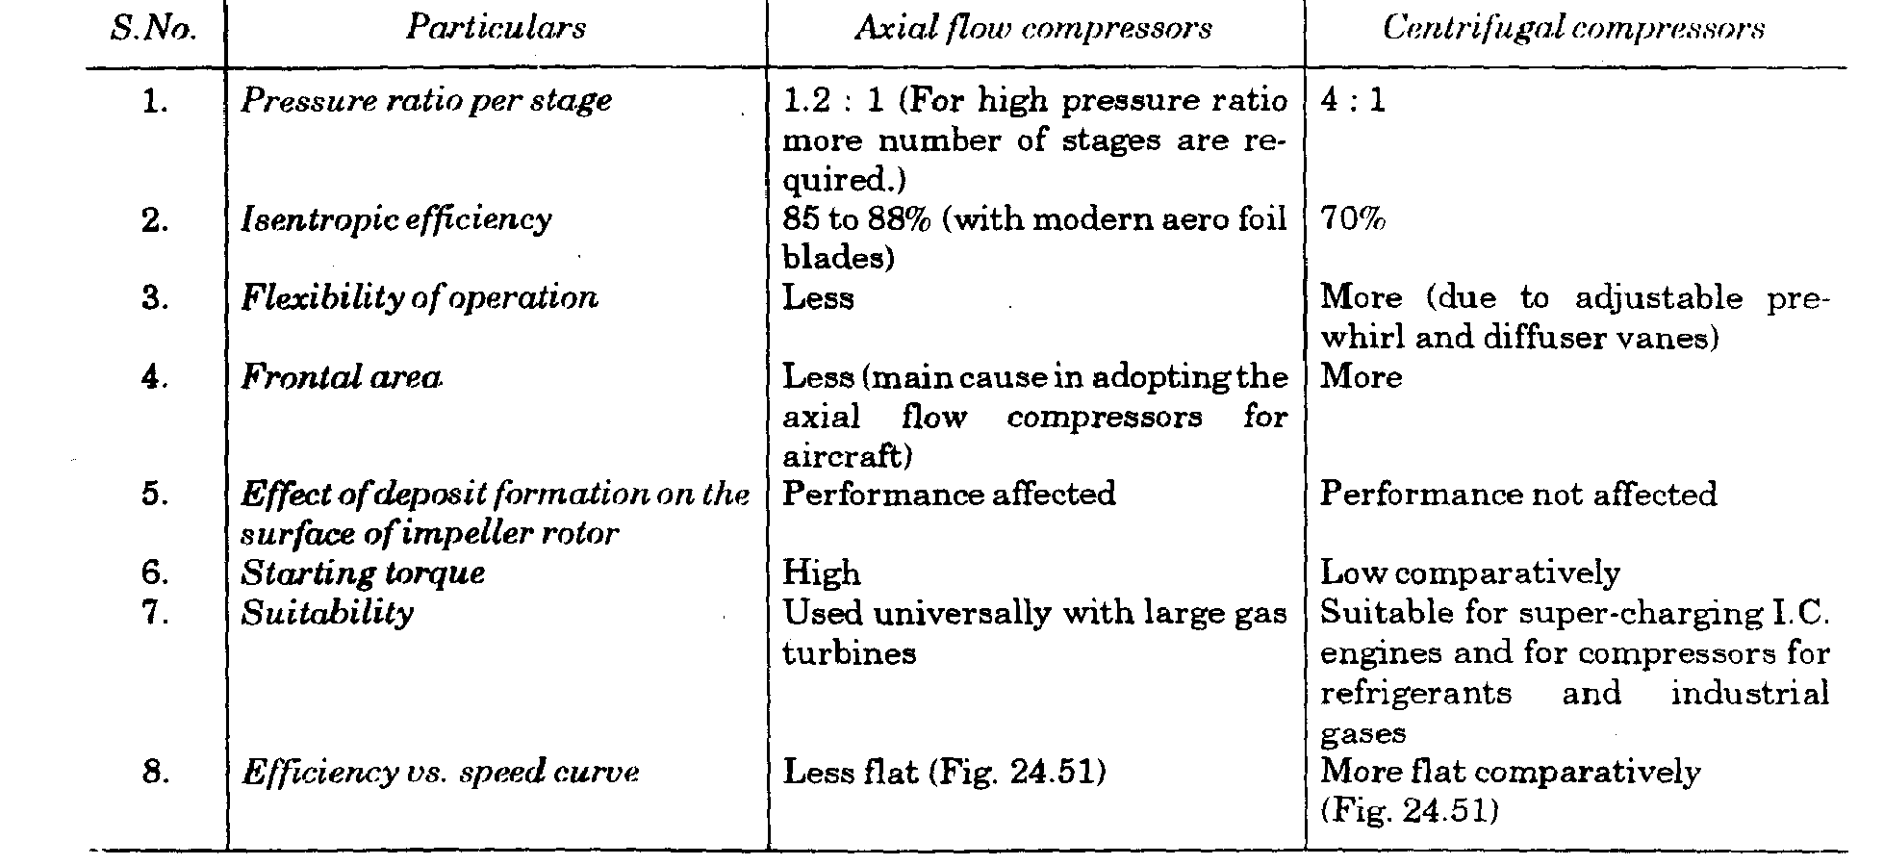

GAS TURBINES
1) What are the applications of Gas Turbines?
Ans.:-1. Supercharging 2. Turbo jet and turbo-propeller engines
3. Marine field 4. Railways
5. Road transport 6. Electric power generation
7. Industry.
2) What are the limitations of gas turbines?
Ans.:-The gas turbines have the following limitations: i) They are not self starting; (ii) low efficiencies at part loads; (iii) non-reversibility; (iv) higher rotor speeds and (v) overall efficiency of the plant low.
3) Classify gas turbines
Ans.:-The gas turbines are mainly divided into two groups:
1. Constant pressure combustion gas turbine
(a) Open cycle constant pressure gas turbine
(b) Closed cycle constant pressure gas turbine.
2. Constant volume combustion gas turbine.
4)List the merits of Gas Turbines over I.C. engines?
Ans.:- Merits of Gas Turbines over I.C. engines:
1. The mechanical efficiency of a gas turbine (95%) is quite high as compared with I.C. engine (85%) .
2. A gas turbine does not require a flywheel as the torque on the shaft is continuous and uniform.
3. The weight of gas turbine per H.P. developed is less than that of an I.C. engine.
4. The gas turbine can be driven at very high speeds (40,000 r.p.m.) whereas this is not possible with I.C. engines.
5. The work developed by a gas turbine per kg of air is more as compared to an I .C. engine
6. The components of the gas turbine can be made lighter since the pressures used in it are very low, say 5 bar compared with I.C. engine, say 60 bar.
7. In the gas turbine the ignition and lubrication systems are much simpler as compared with I.C. Engines.
8. Cheaper fuels such as paraffine type, residue oils or powdered coal can be used whereas special grade fuels are employed in petrol engine to check knocking or pinking.
9. The exhaust from gas turbine is less polluting comparatively since excess air is used for combustion.
10. Because of low specific weight the gas turbines are particularly suitable for use in aircrafts.
5)List the demerits of Gas Turbines over I.C. engines?
Ans.:-Demerits of Gas Turbines over I.C. engines:-
1. The thermal efficiency of a simple turbine cycle is low (15 to 20%) as compared with I.C. engines (25 to 30%).
2. With wide operating speeds the fuel control is comparatively difficult.
3. Due to higher operating speeds of the turbine, it is imperative to have a speed reduction device.
4. It is difficult to start a gas turbine as compared to an I.C. engine.
5. The gas turbine blades need a special cooling system.
6. One of the main demerits of a gas turbine is its very poor thermal efficiency at part loads.
7. Owing to the use of nickel-chromium alloy, the manufacture of the blades is difficult and costly.
8. For the same output the gas turbine produces five times exhaust gases than LC. engine.
9. Because of prevalence of high temperature (1000 K for blades and 2500 K for combustion chamber) and centrifugal force the life of the combustion chamber and blades is short/small.
6)List the advantages of Gas Turbines over steam turbines?
Ans.:-The gas turbine entails the following advantages over steam turbines:
1. Capital and running cost less.
2. For the same output the space required is far less.
3. Starting is more easy and quick.
4. Weight per H.P. is far less.
5. Can be installed anywhere.
6. Control of gas turbine is much easier.
7. Boiler along with accessories not required.
7)Draw typical open cycle and closed cycle gas turbine plants?
Ans.:-
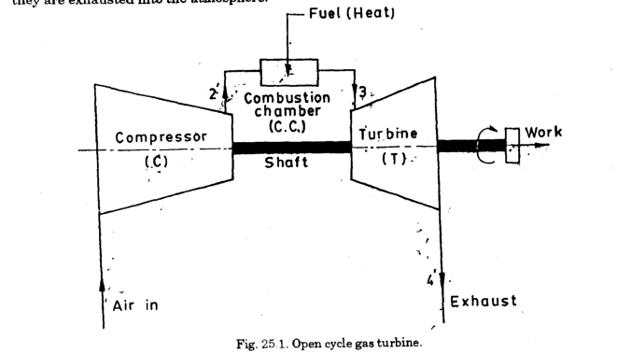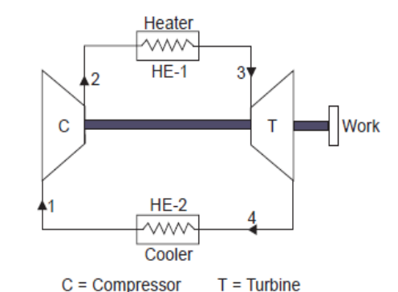

8) What are the methods for Improvement of Thermal Efficiency of Open Cycle Gas Turbine Plant?
Ans.:-The following methods are employed to increase the specific output and thermal efficiency of the plant:
- Inter-cooling 2. Reheating 3. Regeneration.

9) Define Thermal efficiency, Compressor isentropic efficiency and Turbine isentropic efficiency?
Ans.:-
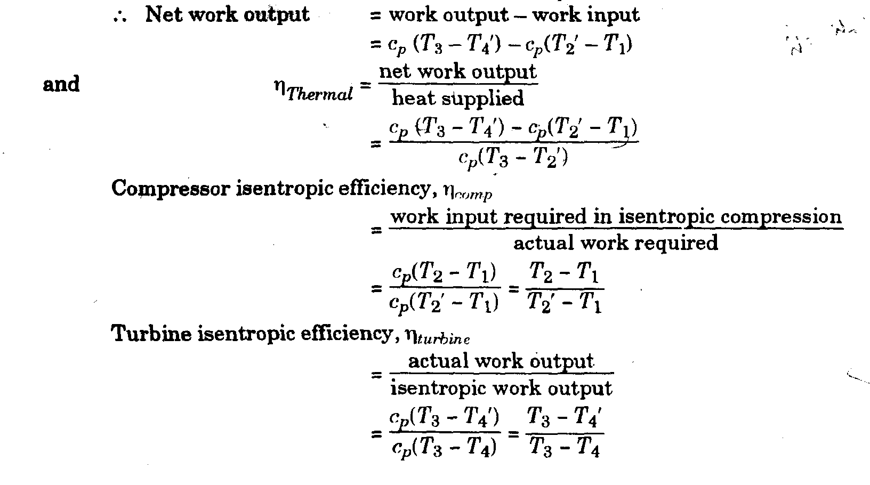

10) Define work ratio and Effectiveness of the heat exchanger?
Ans.:-
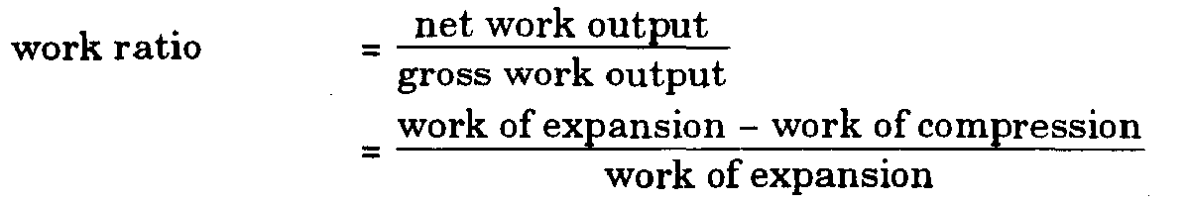
11)What are the Operating Variables Effect Thermal Efficiency
Ans.:-The thermal efficiency of actual open cycle depends on the following thermodynamic Operating Variables
(i) Pressure ratio
(ii) Turbine inlet temperature
(iii) Compressor inlet temperature
(iv) Efficiency of the turbine
(v) Efficiency of the compressor
12) List the merits and demerits of Closed Cycle Gas Turbine over Open Cycle Gas Turbine?
Ans.:-Merits of closed cycle:
1. Higher thermal efficiency 2. Reduced size
3. No contamination 4. Improved heat transmission
5. Improved part load efficiency 6. Lesser fluid friction
7. No loss of working medium 8. Greater output 9. Inexpensive fuel.
Demerits of closed cycle:
1. Complexity
2. Large amount of cooling water is required. This limits its use to stationary installation or marine use where water is available in abundance.3. Dependent system.4. The weight of the system per H.P. developed is high comparatively, therefore not economical for moving vehicles.5. Requires the use of a very large air heater.
13)Draw a typical constant volume combustion turbine plant?
Ans.:- Constant volume combustion turbine
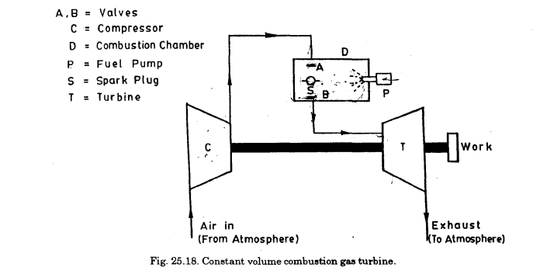

14) Write a short note on fuels used for gas turbines.
Ans.:-
1. Gaseous Fuels: Natural gas is the ideal fuel for gas turbines, but this is not available everywhere.
Blast furnace and producer gases may also be used for gas turbine power plants.
2. Liquid Fuels: Liquid fuels of petroleum origin such as distillate oils or residual oils are most commonly used for gas turbine plant. The essential qualities of these fuels include proper volatility, viscosity and calorific volume. Minerals like sodium, vanadium and calcium prove very harmful for the turbine binding as these build deposits or corrode the blades. In cold conditions residual oils need to be preheated.
3) Solid Fuels: The use of solid fuels such as coal in pulverised form in gas turbines presents several difficulties most of which have been only partially overcome yet. Finely crushed coal is used instead of pulverized fuel
15) Define jet propulsion?
Ans.:-The principle of jet propulsion involves imparting momentum to a mass of fluid in such a manner that the reaction of imparted momentum provides a propulsive force.
16) Classify propulsion system?
Ans.:-The propulsion system may be classified as follows:
1. Air stream jet engine., (Air-breathing engines)
(a) Steady combustion systems ; continuous air flow
(i) Turbo jet (ii) Turbo prop
(iii) Rain jet
(b) Intermittent combustion system ; intermittent flow
(i) Pulse jet or flying bomb.
2. Self contained rocket engines (Non-air breathing engines)
(i) Liquid propellent (ii) Solid propellent
17)What are athodyds?
Ans.:-Athodyds are aero-thermodynamic ducts which are straight duct type of jet engines having no compressor and turbine wheels. Example: ram jet and pulse jet
18) What is the difference between jet propulsion and rocket propulsion?
Ans.:-The main difference is that in case of jet propulsion the oxygen required for combustion is taken from the atmosphere and fuel is stored whereas for rocket engine, the fuel and oxidiser both are contained in a propelling body and as such it can function in vacuum.
19) Define Thrust, Thrust power, Propulsive power, Propulsive efficiency, Thermal efficiency, overall efficiency and jet efficiency?
Ans.:-Thrust is the force produced due to change of momentum
Thrust power (T. P.):It is defined as the rate at which work must be developed by the engine if the air craft is to be kept moving at a constant velocity Ca against friction force or drag.
Thrust power = forward thrust x speed of air craft

Propulsive power (P.P.):
The energy required to change the momentum of the mass flow of gas represents the propulsive power. It is expressed as the difference between the rate of kinetic energies of the entering air and exit gases.
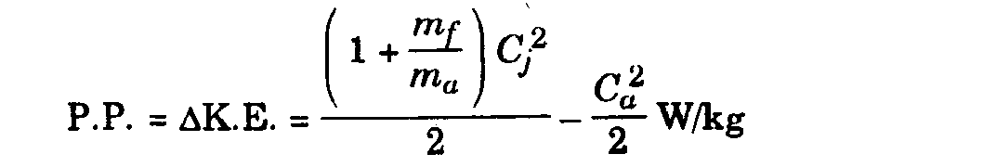
Propulsive efficiency :
The ratio of thrust power to propulsive power is called the Propulsive efficiency of the propulsive unit.
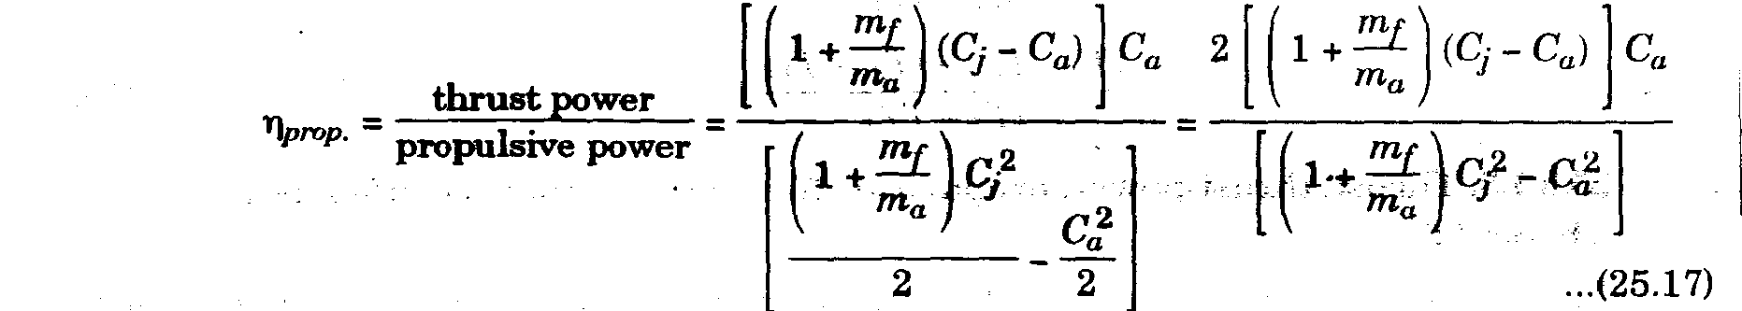
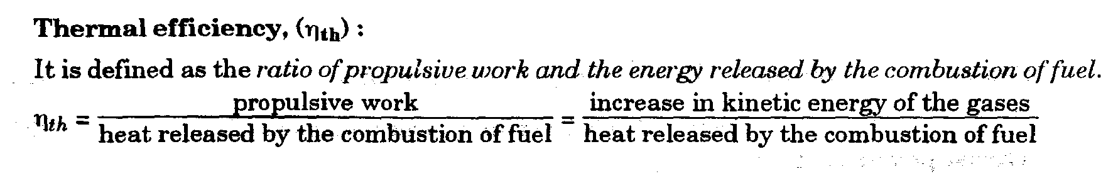
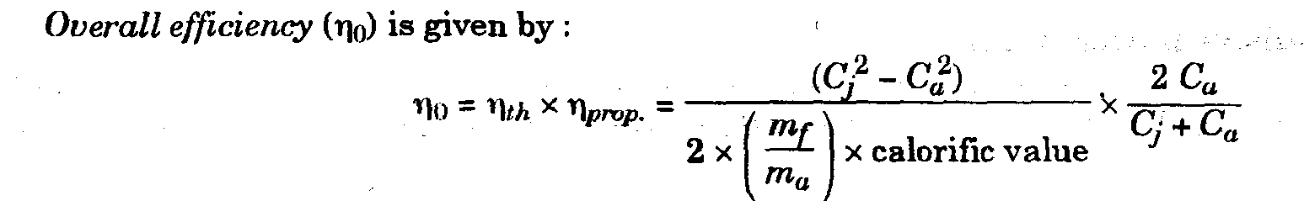
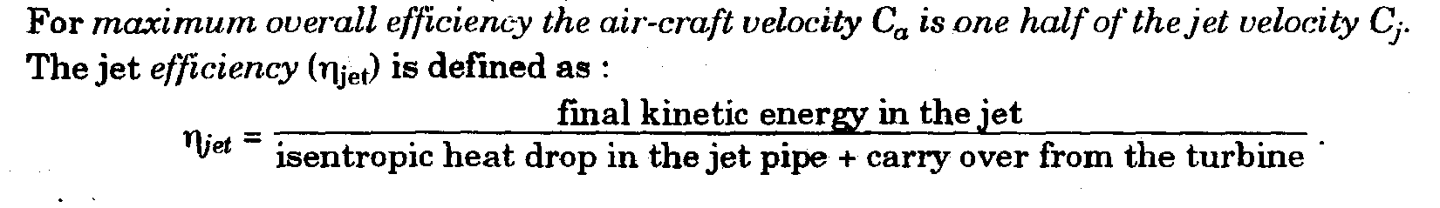
20) Define Rocket propulsion?
Ans.:-The thrust required for rocket propulsion is produced by the high velocity jet of gases passing through the nozzle. But the main difference is that in case of jet propulsion the oxygen required for combustion is taken from the atmosphere and fuel is stored whereas for rocket engine, the fuel and oxidiser both are contained in a propelling body and as such it can function in vacuum.
21) Classify Rocket Engines?
Ans.:-The rockets may be classified as follows;
1. According to the type of propellent:
(i) Solid propellent rocket
(ii) Liquid propellent rocket.
2. According to the number of motors:
(i) Single-stage rocket (consists of one rocket motor)
(ii) Multistage rocket (consists of more than one rocket motor).
22) What are the Requirements of an ideal rocket propellent
An ideal rocket propellent should have the following characteristics/properties:
1. High heat value
2. Reliable smooth ignition
3. Stability and ease of handling and storing
4. Low toxicity and corrosiveness
5. Highest possible density so that it occupies less space.
23) What are the applications of rockets?
The fields of application of rockets are as follows:
1. Long range artillery 2. Lethal weapons 3. Signaling and firework display 4. Jet assisted take-off
5. For satellites 6. For space ships7. Research.
NUCLEAR POWER PLANTS
1) What is Breading?
Ans.:-It is process of producing fissionable material from a fertile material by neutron absorption.
U²³⁸ and Th²³² are fertile materials. They absorb neutrons and produce fissionable materials Pu²³⁹ and U²³³ respectively.
2)What is meant by fertile material?
Ans.:-The material which is not directly fissionable material but can be converted in to fissionable material by neutron absorption. U²³⁸ and Th²³² are fertile materials It has been found that some materials are not fissionable by themselves but they can be converted to the fissionable materials, these are known as fertile materials.
3)What is Radioactivity?
Ans.:-The phenomenon of spontaneous emission of powerful radiations exhibited by heavy elements is called ‘radioactivity’ .Examples are: Uranium, polonium, radium, radon, ionium, thorium, actinium and mesothorium.
4)What is Nuclear Fission ?
Ans.:-Fission is the process that occurs when a neutron collides with the nucleus of certain of the heavy atoms, causing the original nucleus to split into two or more unequal fragments which carry off most of the energy of fission as kinetic energy. This process is accompanied by the emission of neutron and gamma rays.
The below figure is a representation of the fission of uranium ²³⁵. The energy released as a result of fission is the basis for nuclear-power generation. The release of about 2.5 neutrons/fission makes it possible to produce sustained fissioning.
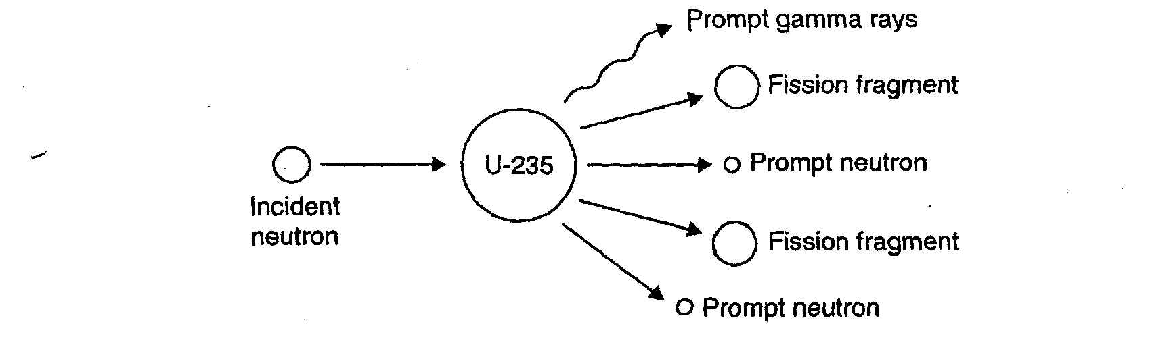
Nuclear Fission:- A reaction in which an atomic nucleus of a radioactive element splits by bombardment from an external source, with simultaneous release of large amounts of energy, used for electric power generation

5)What are the terms Chain reaction and multiplication factor ?
Ans.:-A chain reaction is that process in which the number of neutrons keeps on multiplying rapidly (in geometrical progression) during fission till whole of the fissionable material is disintegrated. The chain reaction will become self-sustaining or self propagating only if, for every neutron absorbed, at least one fission neutron becomes available for causing fission of another nucleus. This condition can be conveniently expressed in the form of multiplication factor or reproduction factor of the system which may be defined as
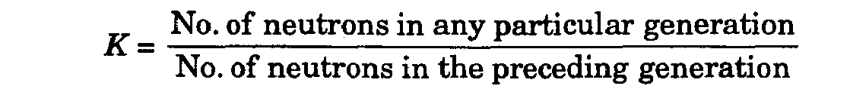
If K> 1, chain reaction will continue and if K < 1, chain reaction cannot be maintained.
6)What is Nuclear Fusion?
Ans.:- ‘Nuclear Fusion’ is the process of combining or fusing two lighter nuclei into a stable and heavier nuclide. Large amount of energy is released because mass of the product nucleus is less than the masses of the two nuclei which are fused.
7)What are the terms Electron Volt, Thermal Neutrons, Fast Neutrons ,Burn Up and Nuclear Cross-sections?
Ans.:-The electron volt is the amount of energy required to raise the potential of an electron by one volt.
One electron volt (eV) = 1.60203 x 10^{_12} erg.= 1.60203 x 10⁻¹⁹ Joules.
Thermal Neutrons are Such neutrons which are in thermal equilibrium with the material in
which they are moving; for example in the moderator. They possess a mean energy of about 0.025 eV, at normal temperature (15°C). Thermal neutrons are the most effective in causing fission and, therefore it is desirable to slow down or moderate the fast neutrons
Fast neutrons are those neutrons which have lost relatively little energy since being produced in the fission process. The lower limit of their energy is taken as 1.0 MeV, (million electron volts).
Burn Up is the amount of fissible material in a reactor that gets destroyed due to fission or neutron capture expressed as a percentage of the original quantity of fissionable materials.
Nuclear Cross-sections (or attenuation coefficients) are measures of the probability that a given reaction will take place between a nucleus or nuclei and incident radiation.
8)What is Nuclear reactor ?
Ans.:-A nuclear reactor is an apparatus in which nuclear fission is produced in the form of a controlled self-sustaining chain reaction. In other words, it is a controlled chain-reacting system supplying nuclear energy. It may be looked upon as a sort of nuclear furnace which burns fuels like U235, U233 or Pu239 and, in turn, produces many useful products like heat, neutrons and radioisotopes.
9)What is Uranium Enrichment?
Ans.:-Uranium Enrichment is the process of increasing the concentration of U²³⁵ more than 0.71% where as natural uranium containing up to 0.71% of U²³⁵ .The various methods of uranium enrichment are as follows:
1. The gaseous diffusion method. 2. Thermal diffusion method. 3. Electromagnetic Method. 4. Centrifugation Method.
10)List down the Uranium Compounds?
Ans.:-
- Uranium metal
- Uranium dioxide ( UO₂ )
- Thriuranium octaoxide ( U₃O₈ )
- Uranium tetrafluoride ( UF₄ )
- Uranium hexafluoride ( UF₆ )
11)Classify Nuclear Reactors?
Ans.:-Nuclear reactors are classified according to the chain reacting system, use, coolants, fuel material etc.
1 Neutron energies at which the fission occurs
(i) Fast fission is caused by high energy neutrons Fast reactors
(ii) Intermediate or epithermal Intermediate reactors
(iii) Low energy i.e., thermal Slow reactors
2. Fuel-moderator assembly
(i) Homogeneous reactors (ii) Heterogeneous reactors.
In ‘homogeneous reactor’ the fuel and moderator are mixed to form a homogeneous material,
i.e., uranium fuel salt forms a homogeneous solution in water which is a moderator or fine particles
of uranium and carbon gives a mechanical mixture.
In ‘heterogeneous reactor’ the fuel is used in the form of rods, plates, lamps or wires and the
moderator surrounds the each fuel element in the reactor core.
3. Fuel state
(i) Solid (ii) Liquid (iii) Gas
12)What are the essential Components of a Nuclear Reactor?
Ans.:-The essential components of a nuclear reactor are as follows:
1. Reactor core 2. Reflector 3. Control mechanism
4. Moderator 5. Coolants 6. Measuring instruments 7. Shielding.
13)What are the major advantages and disadvantages of nuclear power plants ?
Some of the major advantages of nuclear power plants are:
Ans.:-1. A nuclear power plant needs less space as compared to other conventional power plant of equal size.
2. Nuclear power plants are well suited to meet large power demands. They give better performance at high load factors (80 to 90%).
3. Since the fuel consumption is very small as compared to conventional type of power plants, therefore,
there is saving in cost of the fuel transportation.
4. The nuclear power plants, besides producing large amount of power, produce valuable fissionable material
5. The operation of a nuclear power plant is more reliable.
6. Nuclear power plants are not affected by adverse weather conditions.
7. Bigger capacity of a nuclear power plant is an additional advantage.
8. The expenditure on metal structures piping, storage mechanisms is much lower for a nuclear power plant than a coal burning power plant.
Disadvantages/Limitations
1. The capital cost of a nuclear power station is always high.
2. The danger of radioactivity always persists in the nuclear stations (in spite of utmost precautions and care).
3. These plants cannot be operated at varying load efficiently.
4. The maintenance cost is always high (due to lack of standardization and high salaries of the trained personnel in this field of specialization).
5. The disposal of fission products is a big problem.
6. Working conditions in nuclear power station are always detrimental to the health of the workers, which is produced when the fuel is renewed.
14)What are the factors to be considered while selecting the site for a nuclear power plant?
Ans.:-1. Proximity to load centre 2. Population distribution
3. Land use 4. Meteorology5. Geology 6. Seismology7. Hydrology.
15) Explain waste disposal of nuclear power plants?
Ans.:-Waste Disposal
Liquid Wastes:- The disposal of liquid wastes is done in two ways:.
i)Dilution. The liquid wastes are diluted with large quantities of water and then released into the ground. This method suffers from the drawback that there is a chance of contamination of underground water if the dilution factor is not adequate.
(ii) Concentration to small volumes and storage. When the dilution of radioactive liquid wastes is not desirable due to amount or nature of isotopes the liquid wastes are concentrated to small volumes and store in underground tanks. The tanks should be of assured Long term strength and leakage of liquid from the tanks should not take place otherwise leakage or contents, from the tanks may lead to significant underground water contamination.
Gaseous Wastes: Gaseous wastes can most easily result in atmospheric pollution. Gaseous wastes generally diluted with air, passed through filters and then released to atmosphere through large stacks (chimneys).
Solid Wastes. Solid wastes consist of scrap material or discarded objects contaminated with radioactive matter. These wastes if combustible are burnt and the radioactive matter is mixed with concrete, drummed and shipped to burial. Non-combustible solid wastes are always buried deep in the ground.
16) What are the differences between nuclear fission and fusion?
Ans.:-
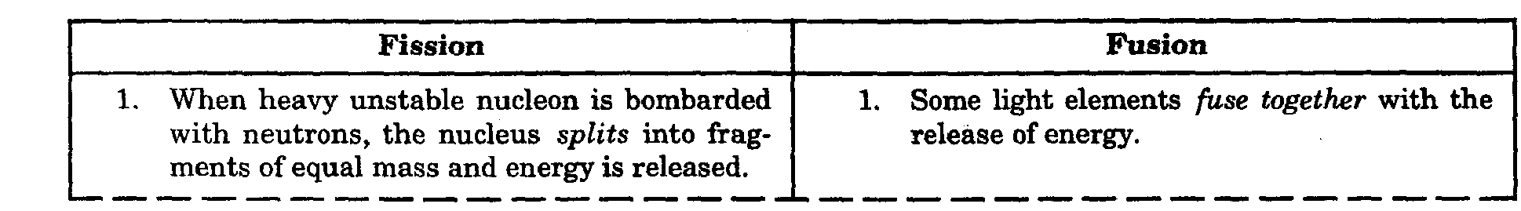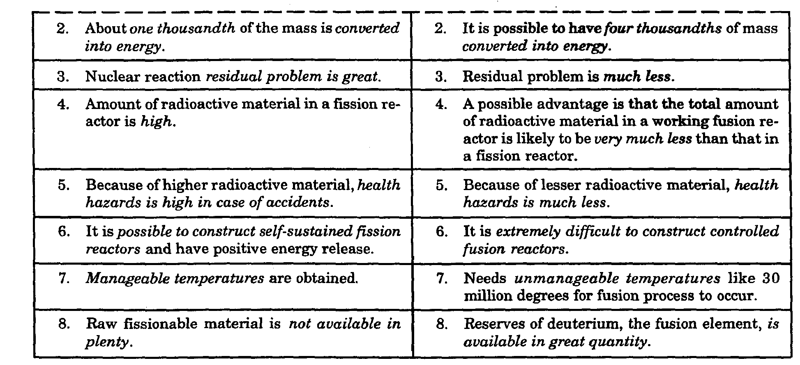
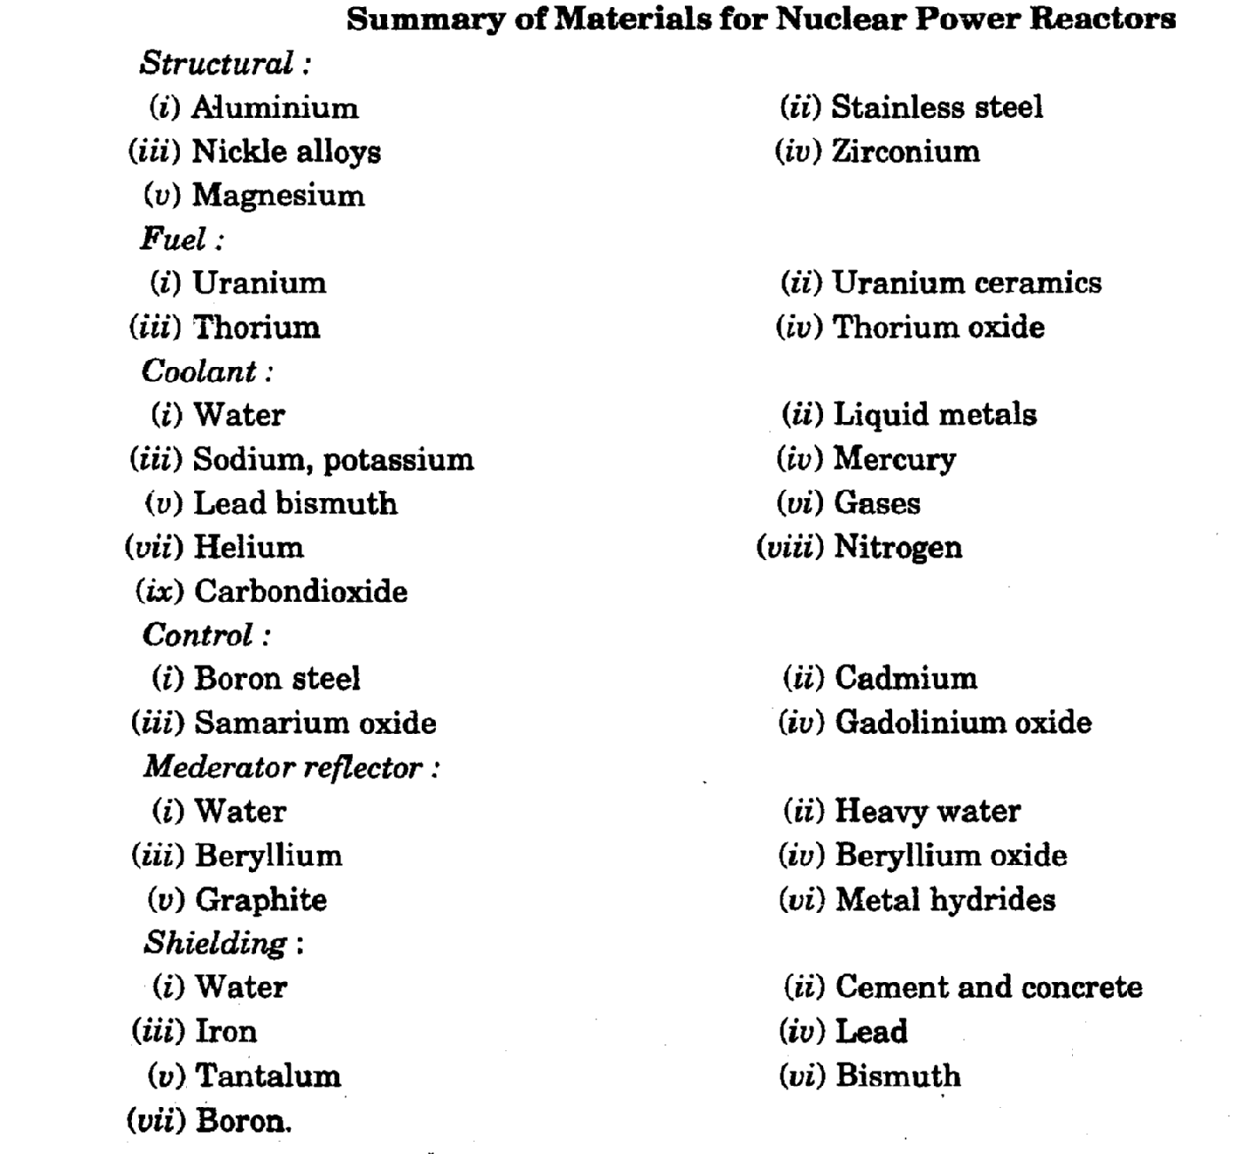
NON CONVENTIONAL ENERGY SOURCES

1) What are the terms direct or beam Radiation and diffuse radiation?
Ans.:-Solar radiation that has not been absorbed or scattered and reaches the ground directly from the sun is called Direct or beam Radiation. It is the Radiation which produces a shadow when interrupted by an opaque object.
The radiation received after scattering is called diffuse radiation. Diffuse radiation comes to earth from all parts of the sky. The total solar radiation received at any point on the earth’s surface is the sum of direct and diffuse radiation.
2)List the applications of Solar Energy?
Ans.:-applications are
(i) water pumping for irrigation and drinking water supply.
(ii) Community and street lighting.
(iii) Power supply for micro wave repeater station.
(iv) Communication equipment, radio and television receivers.
(v) Solar water heaters.
vi) Solar refrigeration.
3)How do you measure Solar Radiation?
Ans.:-Following two types of instruments are used for solar radiation measurement:
{i) Pyrheliometer. It collimates the radiation to determine the beam intensity as a function of incident angle.
(ii) Pyranometer. It measures the total hemi-spherical solar radiation. The pyranometer is quite popular.
4) Define solar constant?
Ans.:-It is the rate at which solar energy arrives at the top of atmosphere .This is the amount of energy received in unit time on unit area perpendicular to the sun’s direction at the mean distance of the earth from the sun.1.353 kilowatts per square meter
5)Classify solar energy collectors?
Ans.:-Types of Collectors
1)Flat Plate Collectors
2)Concentrating Collectors
Concentrating or focusing collectors are of two types
(i) Line focusing collectors
(ii) Point focusing collectors.
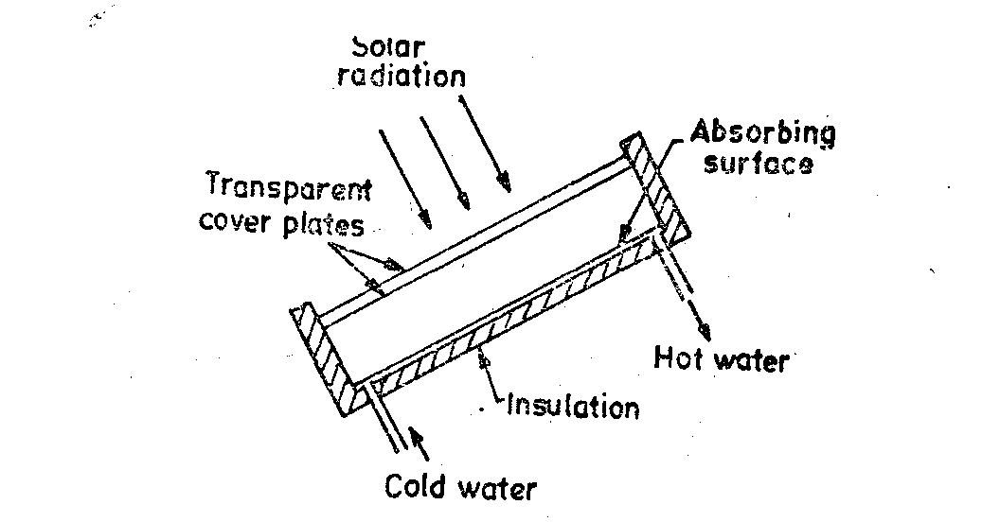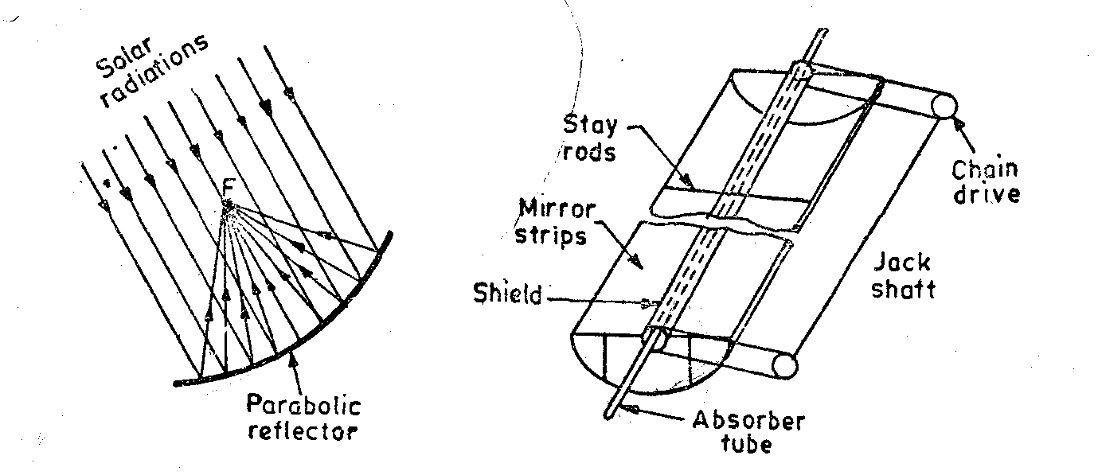
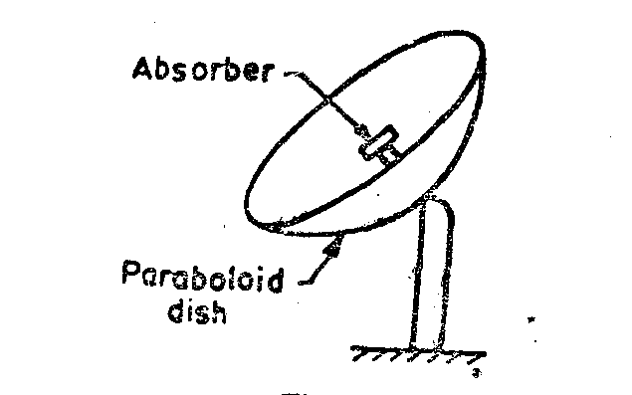
6) What are the advantages and disadvantages of concentrating collectors over flat plate collectors?
Ans.:-Concentrating collectors have the following advantages over flat plate collectors
(i) Reflecting surfaces are structurally simp1ei and need less material.
(ii) Cost of collecting system per unit area is low.
(iii) The absorber area of concentration is small and therefore, solar energy concentrated can produce more heat and therefore, working fluid can attain temperature for the same solar energy falling on the concentrator.
(iv) Since the temperature that can be attained with concentrating collector system is higher, the amount of heat which can be stored per unit volume is larger and consequently the heat storage costs are less for concentrator systems than for flat plate collectors.
(v) They have more efficiency.
Disadvantages
(i) Diffused solar radiations cannot be focused and is lost.
(ii) Initial cost is high.
(iii)Costly orienting system for reflector to track the sun is required.
7) What are the methods to exploit solar energy?
Ans.:-Solar energy can be exploited in various ways as follows:
(i) By direct conversion to a fuel by photosynthesis.
(ii) By direct conversion to electricity by photo voltaic.
(iii) By conversion to electricity via thermo-electric power system.
8) What are the thermo-electric systems used for power generation?
Ans.:-Following thermo-electric systems are presently used for power generation.
(i) Low temperature cycles using flat plate collectors.
(ii) Concentrator collector for medium and high temperature cycles.
(iii) Power concept for power generation.
9) What is a Photovoltaic Cell?
Ans.:-Photovoltaic Cells or Solar Cells directly convert solar energy to D.C. power.
These are made of semiconductors that generate electricity when they absorb light.
10) Classify wind mills ?
Ans.:-I)Horizontal axis wind mills
a) Multi blade type wind mill
b) Sail type wind mill
c) Propeller type wind mill
II) Vertical axis wind mills
a) Savionius type wind mill
b)Darrieus type wind mill
11)What are the various parts of a wind-electric generating power plant?
Ans.:-
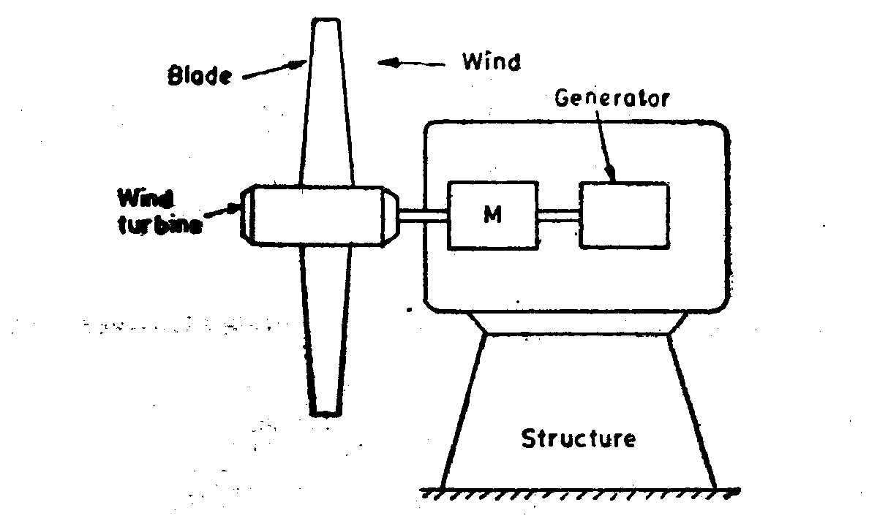

- Wind turbine or rotor
- Wind mill head
- Generator
- Supporting structure.

12) What are the basic Components of a Wind Energy Conversion System (WECS)?

Ans.:-Basic Components of a Wind Energy Conversion System (WECS)
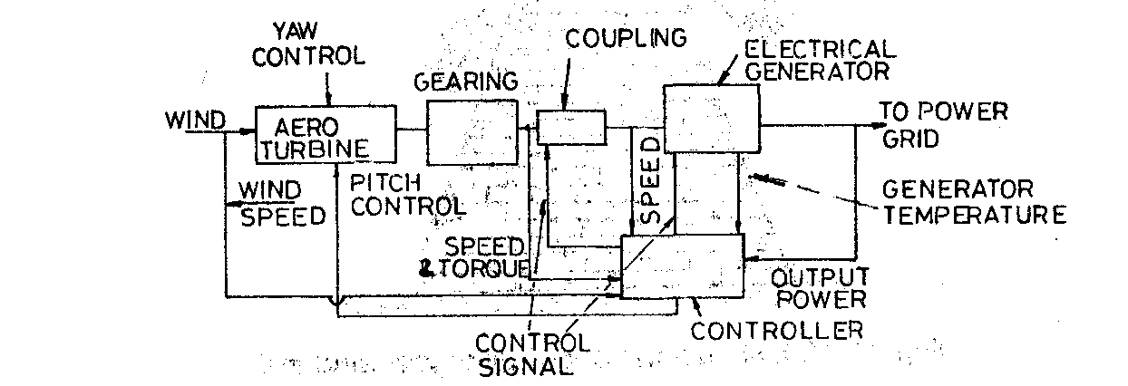

13)What are the advantages and disadvantages of wind energy ?
Ans.:-Advantages
1. It is a renewable energy source.
2. Wind power systems being non-polluting have no adverse effect on the environment.
3. Fuel provision and transport are not required in wind energy conversion systems.
4. Economically competitive.
5. Ideal choice for rural and remote areas and areas which lack other energy sources.
Disadvantages:
1. Owing to its irregularity, the wind energy needs storage.
2. Availability of energy is fluctuating in nature.
3. The overall weight of a wind power system is relatively high.
4. Wind energy conversion systems are noisy in operation.
5. Large areas are required for installation/operation of wind energy systems.
14) What is the principle of MHD Generators?
Ans.:-An MHD generator is a device for converting heat energy directly into electrical energy without a conventional electric generator .MHD power generation uses the interaction of an electrically conducting fluid with a magnetic field to convert part of the energy of the fluid directly into electricity.
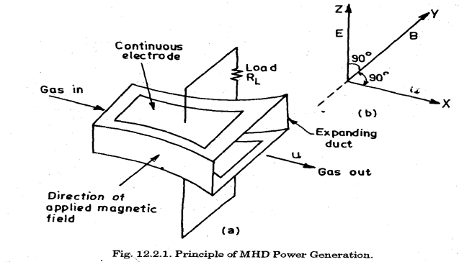
15) Classify MHD Generators?
Ans.:- Types of MHD Generators
1Open Cycle MHD Generators
2.Closed Cycle MHD Generators
- Seeded invert gas system
- Liquid metal system.
16) What are the applications of MHD Generators?
Ans.:-Applications
- Geophysics
- Astrophysics
- Engineering
17) What are the advantages and disadvantages of MHD Generators
Ans.:-Advantages of MHD System
- The size of the plant is considerably smaller than conventional fossil fuel plants.
- It can be started and put on line within few seconds.
- It has high thermal efficiency (50-55%).
- It proves instantaneous standby power. It can be used most economically as peak load plant.
- Closed cycle produces power free from pollution.
- Large amount of power is generated.
Hurdles in the progress of MHD power plant
- Development of super conductor magnet.
- Materials to withstand high temperatures.
- Efficient conversion of DC to AC erosion less electrodes.
- Heavy losses in the power electrodes.
Disadvantages of MHD system
- Heavy losses in the power electrode in MHD power plant.
- The material used in the MHD power plant doesn’t withstand in high temperatures.
18) Explain See beck effect?
Ans.:- See-beck effect:- An e.m.f. is produced when in a loop of two dissimilar metals the junctions are kept at different temperatures.

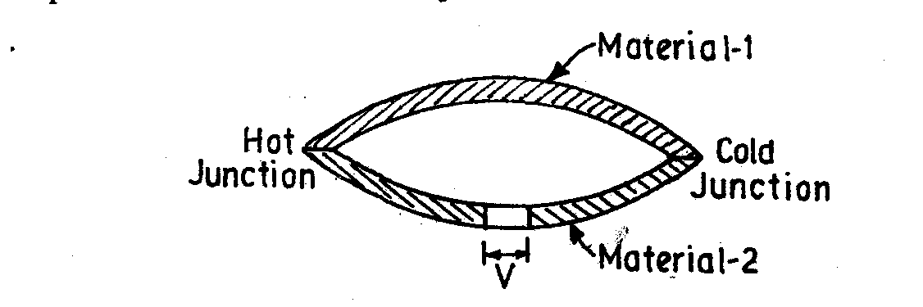
19) What are the materials used thermoelectric power generator?
Ans.:- The commonly used materials in thermoelectric power generator are as follows:
(i) Lead telluride (ii) Bismuth telluride (iii) Bismuth sulfide (iv) Zinc antimonide
(v) Cesium sulfide.
Air Standard Cycles
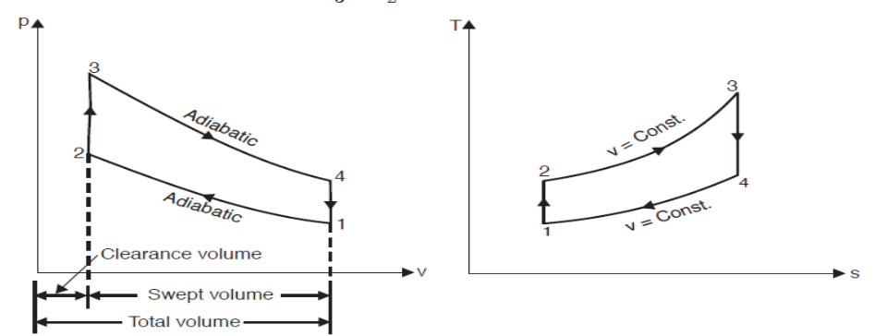
Otto Cycle

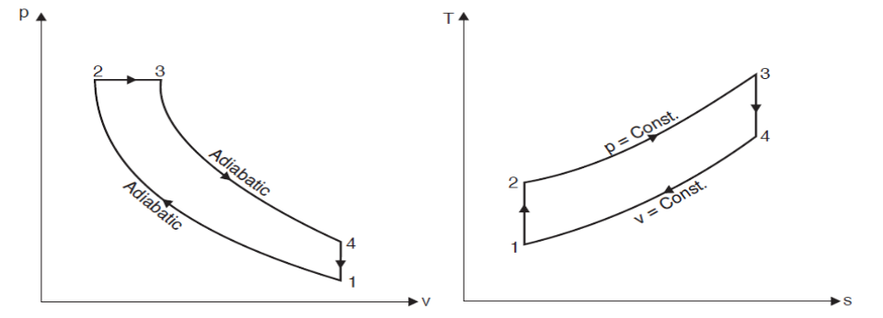
Diesel Cycle

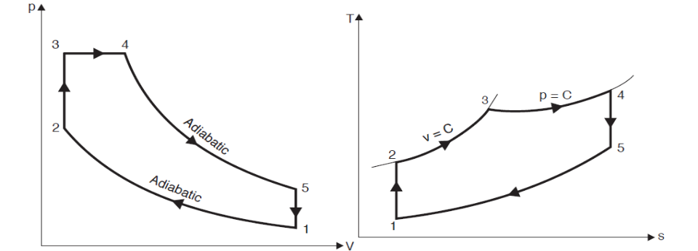
Dual combustion cycle

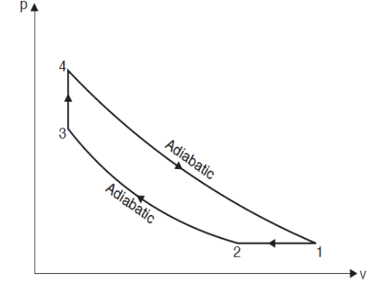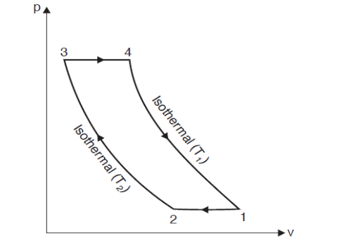
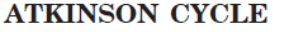
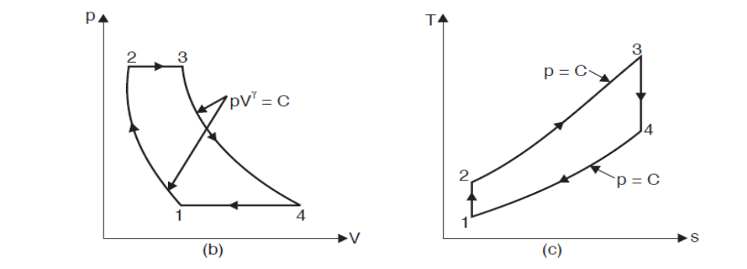
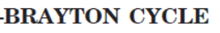

p-V & Valve timing Diagrams of IC engines
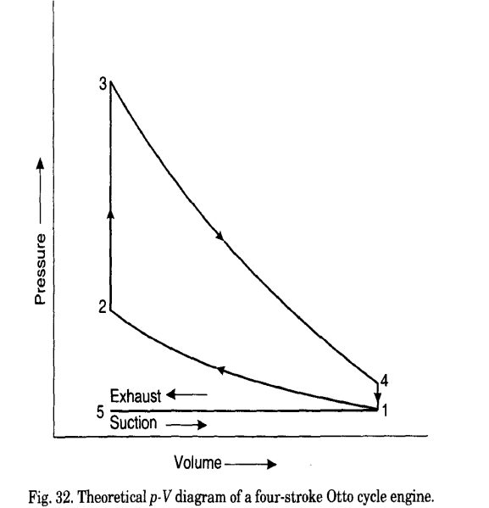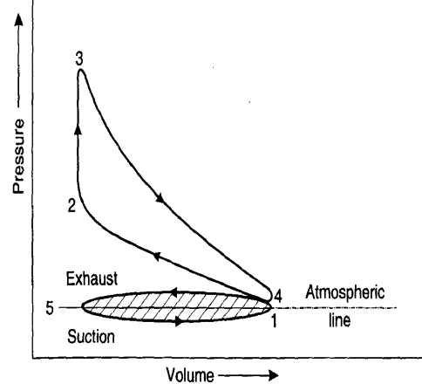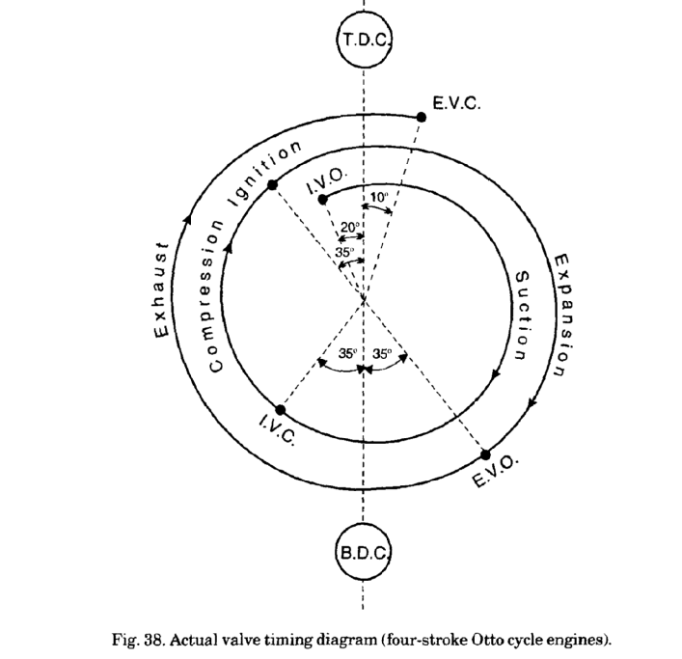
Theoretical p-V diagram of a four-stroke Actual p-V diagram of a four-stroke Valve timing diagram of a four-stroke
Otto cycle

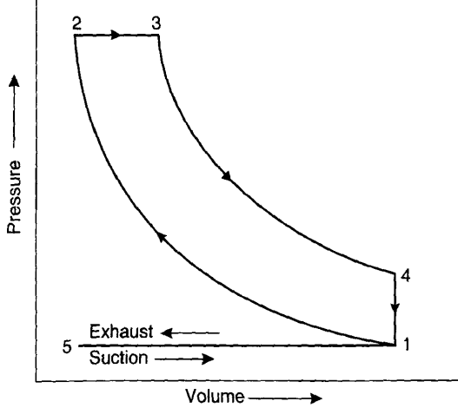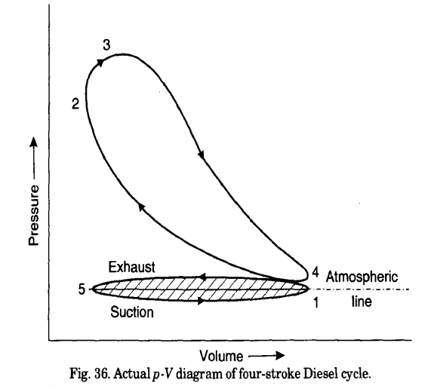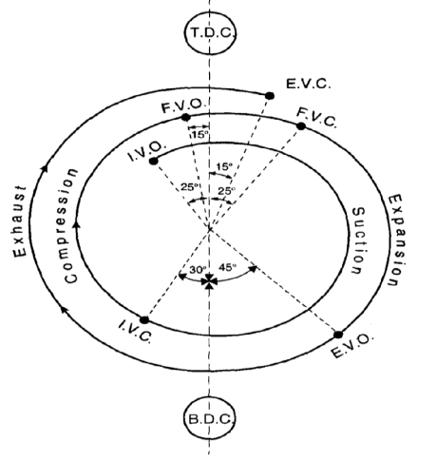
Theoretical p-V diagram of a four-stroke Actual p-V diagram of four-stroke Actual valve timing diagram of a four-stroke
Diesel cycle.
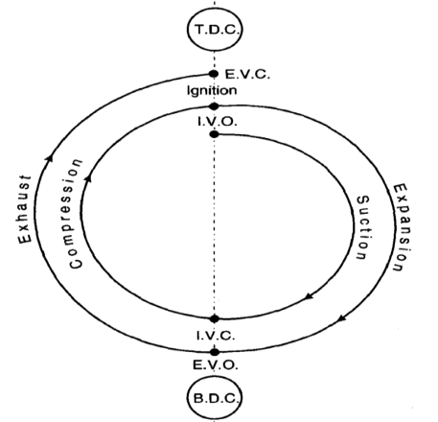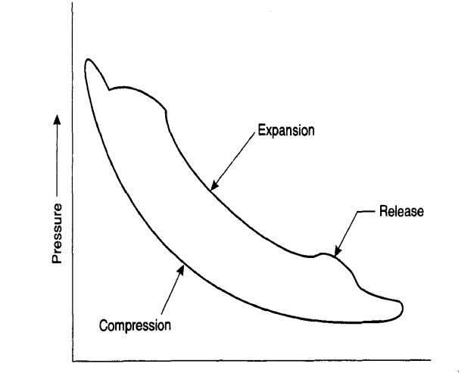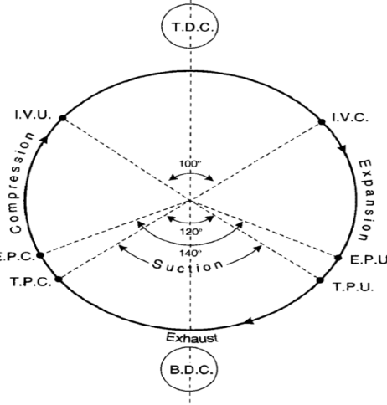
Theoretical Valve Timing Diagram four-stroke p-V diagram for a two-stroke cycle engine. Port timing diagram for two-stroke engine

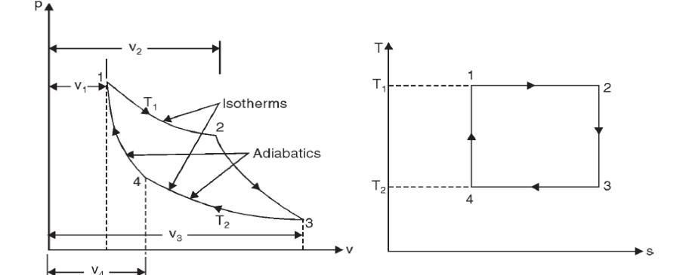
Carnot cycle

